**Data and Visualization**

[Optional: Add an image/logo]

Team 10: Jeevan Rai & Abhilash Narayanan

**Executive Summary:** [¼ page description of the project highlights. The summary needs to answer the following questions: What is the problem you are working on? Why is it important? What are the key results and how are they useful to the reader?]

**Table of Contents**

1 Problem Description 2

2 Data Collection and Data Quality 3

Dataset 1: COVID-19_global_mobility.csv

Dataset 2: COVID-19_cases_TX.csv

Dataset 3: COVID-19_cases_plus_census.csv 3

3 Data Exploration 5

Dataset 1: COVID-19_global_mobility.csv 19

Feature Processing

Data Analysis

Dataset 2: COVID-19_cases_TX.csv 19

Death Percentages for each County 20

Is there any relation between Death Percentage and Median Income?

Dataset 3: COVID-19_cases_plus_census.csv 19

Feature Processing

Data Analysis 20

Is there any relation between Death Percentage and Median Income? 23

3.1 Modeling and Evaluation 24

4 Recommendations 24

5 Conclusion 24

6 List of References 24

7 Appendix 24

7.1 Student Contributions 27

# Problem Description

[**Business Understanding:** Frame the Problem. Add a short description of the problem area. Who is your stakeholder and what does the **stakeholder** want? What are the **questions** you need to answer? Why are they important? What kind of data do you need? Do some research and add references to the Reference section.]

A widespread disease COVID-19 started at the end of 2019, and it quickly spread throughout the entire world impacting every aspect of human society. Since then, there have been several kinds of studies conducted on the impact of this pandemic. The data on those studies are available for the general public. Among those datasets, we will be looking at three different datasets. The primary focus of the analysis is based on understanding the impact of this pandemic on different aspects of human society all around the world since 2019. For an instance, the dataset “Global_Mobility_Report.csv” provides insights into the change in public visits to different locations (like parks, grocery stores, recreational locations, etc.) in response to the policies that the governments of different countries implemented to combat against COVID-19 between 2020 and 2021. Additionally, data mining is performed on these datasets to understand any existing relationships between entities. This can be used to predict recurrence of similar pandemic in the near future and the consequences of such situations.

The insights generated from these analyses can be utilized by the leaders of various government functions to establish necessary preventative measures. For example, organizations such as Centers for Disease Control and Prevention (CDC) could allocate resources in necessary preventative measures and contingency plans if a similar pandemic occurs in the future. Such measures not only save the lives of the people, they could save the billions or trillions of government spending that come with such pandemics. For example, the total spending by the US Department of Health and Human Services was $4.7 trillion as of October 2024 (see reference). The dataset “Global_Mobility_Report.csv “ can be used by public health officials to understand the impact of public visits to different places due to the pandemic. Such observations can help them to further understand the effectiveness of the policies that they implemented to combat against the pandemic. If we go into a more granular level, this sort of analysis can be very helpful for business owners of all sizes. These business institutions could implement necessary preventative and contingency measures to protect the business and their employees.

As there is a large amount of information embedded within these datasets, several meaningful and important questions could be answered. For example, using the dataset “Global_Mobility_Report.csv” the health officials of a specific country could answer if their policies were effective based on the public visits to different places. We could compare the public movement between 2020 and 2021. The government officials not only can understand the effectiveness of their policies, they can also compare themselves to other countries’ policies to combat against the pandemic.

# Data Collection and Data Quality

[**Data Understanding part 1**: Describe data source, expected data quality and reliability. If you have several sources, how can you combine the data? At this point, you want to clean the variable names so they are better readable later on.]

The dataset “Global_Mobility_Report.csv” is from the report collected by COVID-19 Community Mobility Reports (see source link below). Although there are some missing values in many feature columns, the overall data quality is high as it was collected by a reliable platform. Depending on the nature of the data, the missing values could be replaced or removed while maintaining the quality of the data for data mining. All 14 variables in the dataset have been labeled appropriately for a user to understand the nature of the dataset.

**---------------------------------------Abhilash start------------------------------------------------------------------------------**

## Dataset 2: COVID-19_cases_TX.csv

This dataset holds the confirmed COVID cases and deaths for each county in Texas for the timeframe between

The attributes that are available in the data set are noted in the below table:

| Attribute Name | Attribute Summary |
| --- | --- |
| county_fips_code | Min. : 0  1st Qu.:48125  Median :48253  Mean :48065  3rd Qu.:48381  Max. :48507 |
| county_name | Length:94350  Class :character  Mode :character |
| state | Length:94350  Class :character  Mode :character |
| state_fips_code | Min. :48  1st Qu.:48  Median :48  Mean :48  3rd Qu.:48  Max. :48 |
| date | Min. :2020-01-22  1st Qu.:2020-04-23  Median :2020-07-24  Mean :2020-07-24  3rd Qu.:2020-10-25  Max. :2021-01-25 |
| confirmed_cases | Min. : 0.0  1st Qu.: 1.0  Median : 82.0  Mean : 2158.6  3rd Qu.: 639.8  Max. :297629.0 |
| deaths | Min. : 0.00  1st Qu.: 0.00  Median : 2.00  Mean : 38.19  3rd Qu.: 15.00  Max. :4024.00 |

The quality of the data is overall good. Below are the cleaning activities that would be performed on this dataset:

* For some of the observations, the County could not be identified, As we are performing our analysis at county level, These records are invalid for this analysis purpose. Hence the dataset will be cleaned by removing these observations.
* The data type of the date column will be converted to date so that analysis is easier with the correct data type.

**---------------------------------------Abhilash end-----------------------------------------------------------------------------**

## Dataset 2: COVID-19_cases_plus_censu.csv

The dataset “COVID-19_cases_plus_census” is extracted from USAFacts US Coronavirus Database (USAFacts). The dataset has 259 feature columns and 3142 observations. These observations represent US COVID-19 cases and death counts for all US states and counties. As per the site, the data is collected from the CDC, and state and local health agencies. This is made available for the general public and is hosted in Google BigQuery. Since the source of the dataset is from the government functions, the quality is reliable and is of high quality.

To maintain the focus of the analysis limited to specific aspects of the dataset, there were many feature columns removed or updated. Shown below are some variable cleaning processes implemented.

* All the values in the feature columns, representing less than 50% spent on rent, were added to update a single value in the new column “rent_under_50_percent”. The values in the “rent_over_50_percent” were left unchanged. So, the previous features columns representing the counts for less than 50% on rent were removed.
* To limit focus on the financial structure of the families, the feature columns that represent various structures of the families (for example, count of children, count of parents, etc.) were removed from the dataset
* The features columns containing data on various income ranges were combined to form four new columns. These columns divided the income data from 0 to 200K and above in 50K range.

Refer to the “DataMining_Project1_plus_census” file for the entire feature processing performed on the dataset. The table above shows the remaining feature columns with their statistics.

# Data Exploration

[**Data Understanding part 2:** Inspect **data quality** and clean data. Present descriptive **statistics** (e.g., in the table shown below) including how much data you have before and after cleaning. Use appropriate visualization (**histograms, bar charts, scatter plots**, etc.) and methods like **correlations**. Discuss what we can learn from exploring the data and what **recommendations** you can give based on your findings.

Do not use screenshots. Use copy paste to copy tables and charts from your R Notebook rendered as HTML or a Word Document into this document and format them in Word appropriately. Add captions in Word. You will need to adjust the axis label font sizes to make them readable. Labels in figures should be roughly the same size as regular text in the document.]

## **Dataset 1: COVID-19_global_mobility.csv**

'data.frame': 3991405 obs. of 14 variables:

$ **country_region_code**  : chr "AE" "AE" "AE" "AE" ...

$ **country_region**  : chr "United Arab Emirates" "United Arab Emirates" "United Arab Emirates" "United Arab Emirates" ...

$ **sub_region_1** : chr "" "" "" "" ...

$ **sub_region_2** : chr "" "" "" "" ...

$ **metro_area** : chr "" "" "" "" ...

$ **iso_3166_2_code** : chr "" "" "" "" ...

$ **census_fips_code** : int NA NA NA NA NA NA NA NA NA NA ...

$ **date** : chr "2020-02-15" "2020-02-16" "2020-02-17" "2020-02-18" ...

$ **retail_and_recreation_percent_change_from_baseline**: int 0 1 -1 -2 -2 -2 -3 -2 -1 -3 ...

$ **grocery_and_pharmacy_percent_change_from_baseline** : int 4 4 1 1 0 1 2 2 3 0 ...

$ **parks_percent_change_from_baseline** : int 5 4 5 5 4 6 6 4 3 5 ...

$ **transit_stations_percent_change_from_baseline** : int 0 1 1 0 -1 1 0 -2 -1 -1 ...

$ **workplaces_percent_change_from_baseline** : int 2 2 2 2 2 1 -1 3 4 3 ...

$ **residential_percent_change_from_baseline** : int 1 1 1 1 1 1 1 1 1 1 …

Internal structure of dataset “COVID_19_global_mobility”

**country_region_code** **country_region** **sub_region_1** **sub_region_2**

135 135 1861 9916

**metro_area** **iso_3166_2_code** **census_fips_code**

66 2225 2838

Count of unique values in the columns

Shown above are the internal structures of the dataset “COVID-19_global_mobility” and the counts of unique values in each of the 14 feature columns or variables. The dataset has 3991405 observations. Following are brief details on the variables:

1. **country_region_code**: Two letters country code, character type, 135 unique codes
2. **country_region**: Country name, character type, 135 unique country names
3. **sub_region_1**: character type, 1861 unique sub regions of different countries, contains the name of a primary administrative subdivision within the country, such as a state, province, or region.
4. **sub_region_2**: character type, 9916 unique sub regions of different countries, contains the name of a secondary administrative subdivision within the primary subdivision, such as a county, district, or municipality
5. **metro_area**: character type, 66 unique metropolitan areas of different countries, areas typically encompass a central city and its surrounding suburbs and exurbs.
6. **iso_3166_2_code**: character type, 2225 unique codes (two letter country code followed by two letter province code)
7. **census_fips_code**: character type, 2838 unique codes (two letters code for US state followed by two letters code for its county)
8. **date**: character type which represents date of observations, observations from 2020 to 2021
9. **retail_and_recreation_percent_change_from_baseline**: integer data type which simply indicate the percentage changes in visits to retail and recreation sectors to the baseline (i.e. before COVID-19 pandemic)
10. **grocery_and_pharmacy_percent_change_from_baseline**: integer data type which indicates the percentage changes in visits to grocery and pharmacy sectors to the baseline
11. **parks_percent_change_from_baseline**: integer data type which indicates the percentage change in the visits to parks to the baseline
12. **transit_stations_percent_change_from_baseline**: integer data type which indicates the percentage change in the visits to transit stations (like public bus stations, train stations, etc.) to the baseline
13. **workplaces_percent_change_from_baseline**: integer data type which indicates the percentage change in the visits to workplaces to the baseline
14. **residential_percent_change_from_baseline**: integer data type which indicates the percentage change in amount of time people spent in residential locations compared to the baseline

**census_fips_code**  **retail_and_recreation_percent_change_from_baseline**

Min. : 1001 Min. :-100.0

1st Qu.:18105 1st Qu.: -41.0

Median :29115 Median : -19.0

Mean :30356 Mean : -23.2

3rd Qu.:45051 3rd Qu.: -4.0

Max. :56045 Max. : 545.0

NA's :3139208 NA's :1478424

**grocery_and_pharmacy_percent_change_from_baseline**

Min. :-100

1st Qu.: -14

Median : -2

Mean : -3

3rd Qu.: 9

Max. : 615

NA's :1564666

**parks_percent_change_from_baseline**

Min. :-100.0

1st Qu.: -44.0

Median : -17.0

Mean : -9.5

3rd Qu.: 11.0

Max. :1206.0

NA's :2080860

**transit_stations_percent_change_from_baseline**

Min. :-100.0

1st Qu.: -48.0

Median : -28.0

Mean : -27.2

3rd Qu.: -7.0

Max. : 554.0

NA's :1973496

**workplaces_percent_change_from_baseline**

Min. :-100.00

1st Qu.: -32.00

Median : -19.00

Mean : -20.07

3rd Qu.: -5.00

Max. : 260.00

NA's :189760

**residential_percent_change_from_baseline**

Min. :-46.0

1st Qu.: 4.0

Median : 8.0

Mean : 9.4

3rd Qu.: 14.0

Max. : 65.0

NA's :1678955

Shown above is basic statistical information on all the feature columns that contain values of numerical data type. For example, we can see that there are census fips code 1001 to 56045. The values in the column **“**residential_percent_change_from_baseline” range from -46 to 65. We can see that there are missing values in all feature columns. See below for the percentage of missing values in each feature column.

country_region 0.00

iso_3166_2_code 0.00

census_fips_code 78.65

retail_and_recreation_percent_change_from_baseline 37.04

grocery_and_pharmacy_percent_change_from_baseline 39.20

parks_percent_change_from_baseline 52.13

transit_stations_percent_change_from_baseline 49.44

workplaces_percent_change_from_baseline 4.75

residential_percent_change_from_baseline 42.06

year_month 0.00

Here is a quick summary of the variables that have non-character data type. Let’s take the variable “census_fips_code” where we can see that the code for “census_fips_code” goes from 1001 to 56045. The mean of the values is 30356. We can also see it has 3139208 (out of 3991405)observations as “NA”. This means it has about 78% of the values not available. Similar interpretations can be made for the remaining variables.

**Feature Processing**

Since the variable “country_region” already has names of the countries, we can ignore the variable “country_region_code”. The metropolitan areas in the “metro” column represent only the areas of certain countries in the “country_region” column. Additionally, the focus of the analysis will be limited to the province of certain countries. Thus, the variable “metro” can be ignored. Similarly, the variables “sub_region_1” and “sub_region_1” can be ignored from the dataset.

*# Convert the date column to Date type and extract year and month*

dataset_global_mobility **<-** dataset_global_mobility **%>%**

mutate(date **=** as.Date(date, format **=** "%Y-%m-%d")) **%>%**

mutate(year_month **=** format(date, "%Y-%m"))

For the variable “date”, the data type is of “char” which means they will need to be converted to date type. Since the focus on the trend analysis month-month and year-year, the converted values will be extracted to keep only the year and month. See above.

*# Drop irrelevant columns*

dataset_global_mobility **<-** dataset_global_mobility **%>%**

select(**-**country_region_code, **-**metro_area, **-**sub_region_1, **-**sub_region_2, **-**date)

*# Remaining feature columns*

names(dataset_global_mobility)

1. 'country_region'
2. 'iso_3166_2_code'
3. 'census_fips_code'
4. 'retail_and_recreation_percent_change_from_baseline'
5. 'grocery_and_pharmacy_percent_change_from_baseline'
6. 'parks_percent_change_from_baseline'
7. 'transit_stations_percent_change_from_baseline'
8. 'workplaces_percent_change_from_baseline'
9. 'residential_percent_change_from_baseline'
10. 'year_month'

After removing irrelevant features from the dataset, here are the feature columns that will be used to make analysis on the dataset. We can see that we removed 4 features from the initial dataset.

Since there are about 78% missing values in the column “census_fips_code”. These values are for countries other than the United States since other countries do not have states. This has been validated by looking at the missing values in this column for other countries as shown below. This feature column will not be utilized when analyzing any statistical trends related to other countries than the United States. Since the majority of these missing values are for countries other than the United States, dummy codes can be assigned to these remaining 134 countries in the “census_fips_code” column. Shown below are 20 dummy fips codes assigned to the 20 countries. Now the remaining missing values are the United States that are not accounted for in the dataset. This is only about 0.43% of the dataset which is a very small portion of the dataset. So these missing values are removed from the dataset.

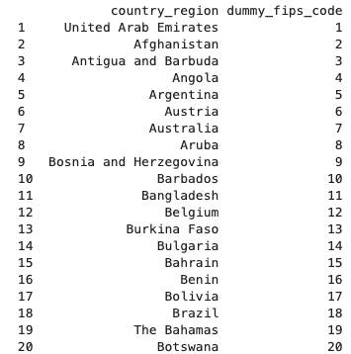

The feature column “retail_and_recreation_percent_change_from_baseline” has about 37% missing values which is a significant portion of the observations in the dataset. These missing values for specific regions based on the “iso_3166_2_code” column are replaced with the corresponding region’s average value. There are certain regions that have only missing values (about 5000 observations) within this feature column. Since these remaining missing values are not that significantly big, they are removed completely from the dataset. Shown below shows this feature processing technique implemented.

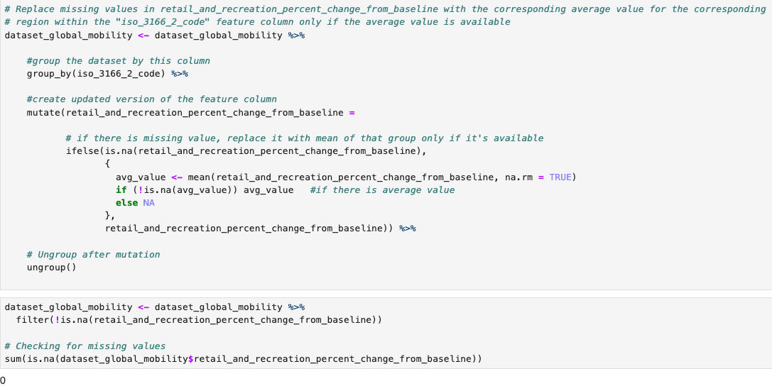

Similar feature processing technique is applied to “grocery_and_pharmacy_percent_change_from_baseline”, “parks_percent_change_from_baseline”, “transit_stations_percent_change_from_baseline”, and “residential_percent_change_from_baseline” since they contain about 39%, 52%, 49%, and 42% of missing values respectively. There are only about 4% missing values in the feature column “workplaces_percent_change_from_baseline”. So, the observations with these missing values are removed from the dataset.

tibble [3,639,804 × 10] (S3: tbl_df/tbl/data.frame)

$ **country_region** : chr [1:3639804] "United Arab Emirates" "United Arab Emirates" "United Arab Emirates" "United Arab Emirates" ...

$ **iso_3166_2_code** : chr [1:3639804] "" "" "" "" ...

$ **census_fips_code** : int [1:3639804] 1 1 1 1 1 1 1 1 1 1 ...

$ **retail_and_recreation_percent_change_from_baseline**: num [1:3639804] 0 1 -1 -2 -2 -2 -3 -2 -1 -3 ...

$ **grocery_and_pharmacy_percent_change_from_baseline** : num [1:3639804] 4 4 1 1 0 1 2 2 3 0 ...

$ **parks_percent_change_from_baseline** : num [1:3639804] 5 4 5 5 4 6 6 4 3 5 ...

$ **transit_stations_percent_change_from_baseline** : num [1:3639804] 0 1 1 0 -1 1 0 -2 -1 -1 ...

$ **workplaces_percent_change_from_baseline** : int [1:3639804] 2 2 2 2 2 1 -1 3 4 3 ...

$ **residential_percent_change_from_baseline** : num [1:3639804] 1 1 1 1 1 1 1 1 1 1 ...

$ **year_month** : Date[1:3639804], format: "2020-02-01" "2020-02-01" ...

After all the feature processing, here is the quick overview of the updated dataset. There are now 3639804 observations and 10 variables as compared to 3991405 observations and 14 variables in the original dataset. This means that about 8% of the observations were removed from the original dataset as they were missing values. However, there is still a sufficient amount of data left to perform various kinds of data mining.

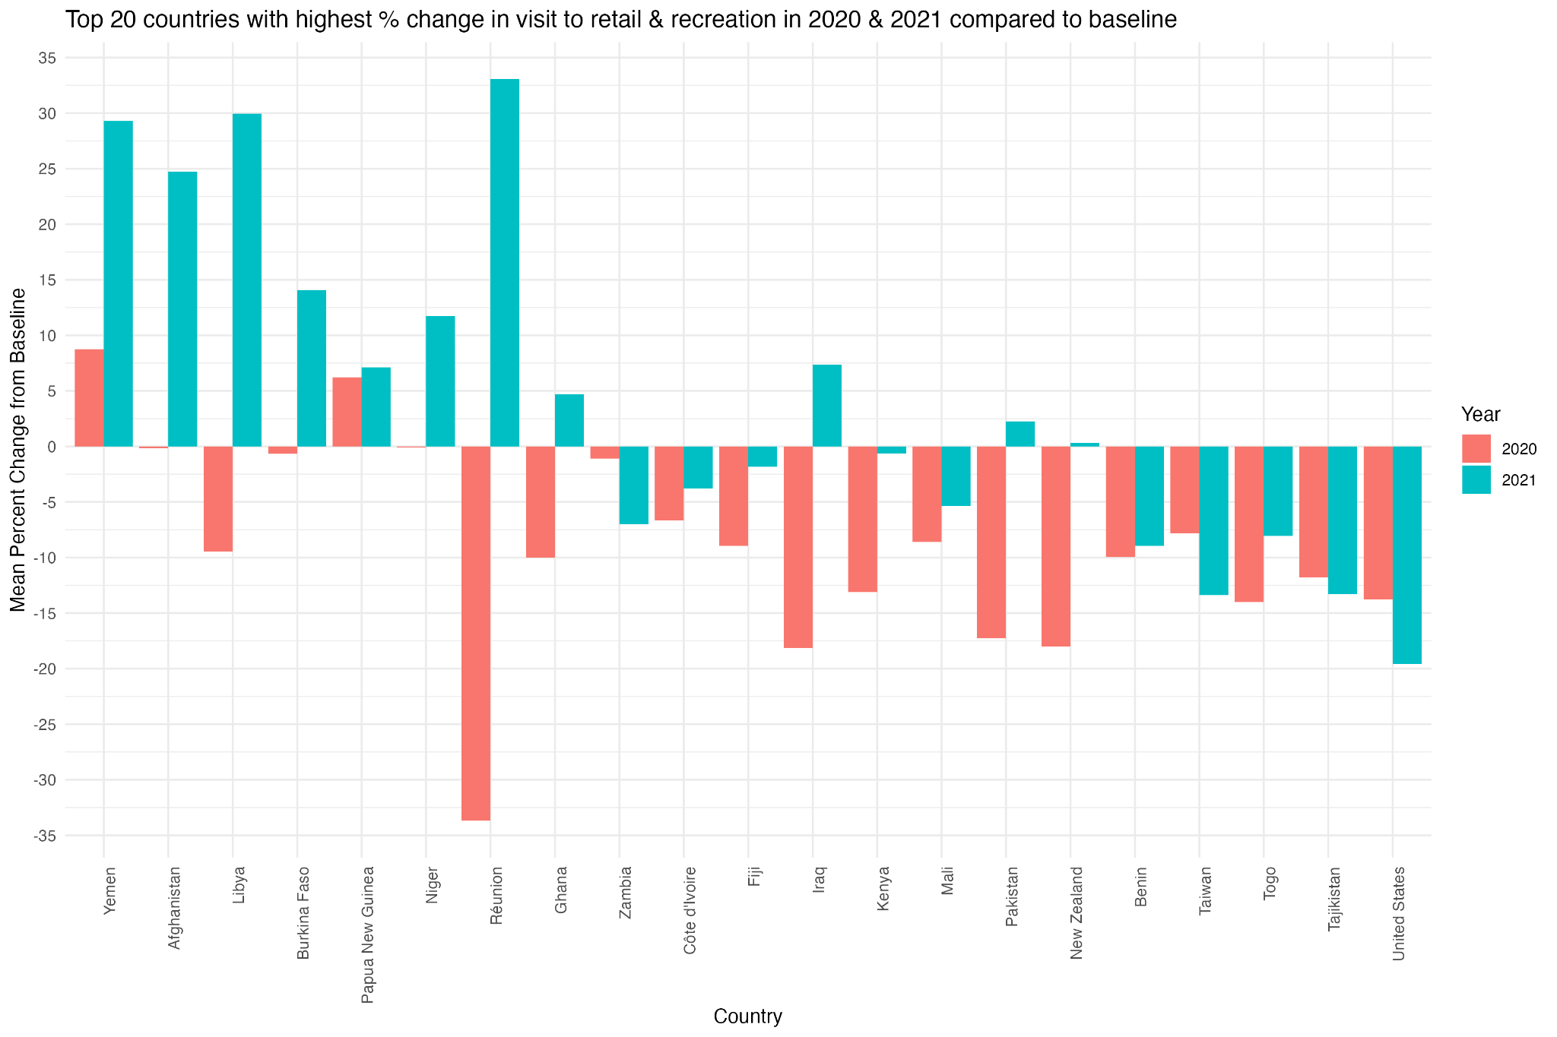

The above plot shows change (in percentage) in people's visits to retail and recreation locations for various countries between 2020 and 2021 when compared to baseline. The baseline is a value (normal) given to a day of the week. This day is the median value from the 5-week period (i.e. Jan 3 to Feb 6, 2020). As the analysis for an entire year for a specific country, the baseline is the aggregate of the individual observations recorded for the given year. The chart only focuses on the 20 countries (and the United States) with the highest change. We can clearly see that the visits to these locations in 2020 were significantly lower as compared to the year before COVID-19. For example, Reunion and New Zealand saw the slowdown by about 34% and 18% respectively. But only after a year, there were many countries that saw an increase in the number of visits to these locations again. For example, Reunion and Libya saw an increase of these visits by about 33% and 30% respectively.

**Data Analysis**

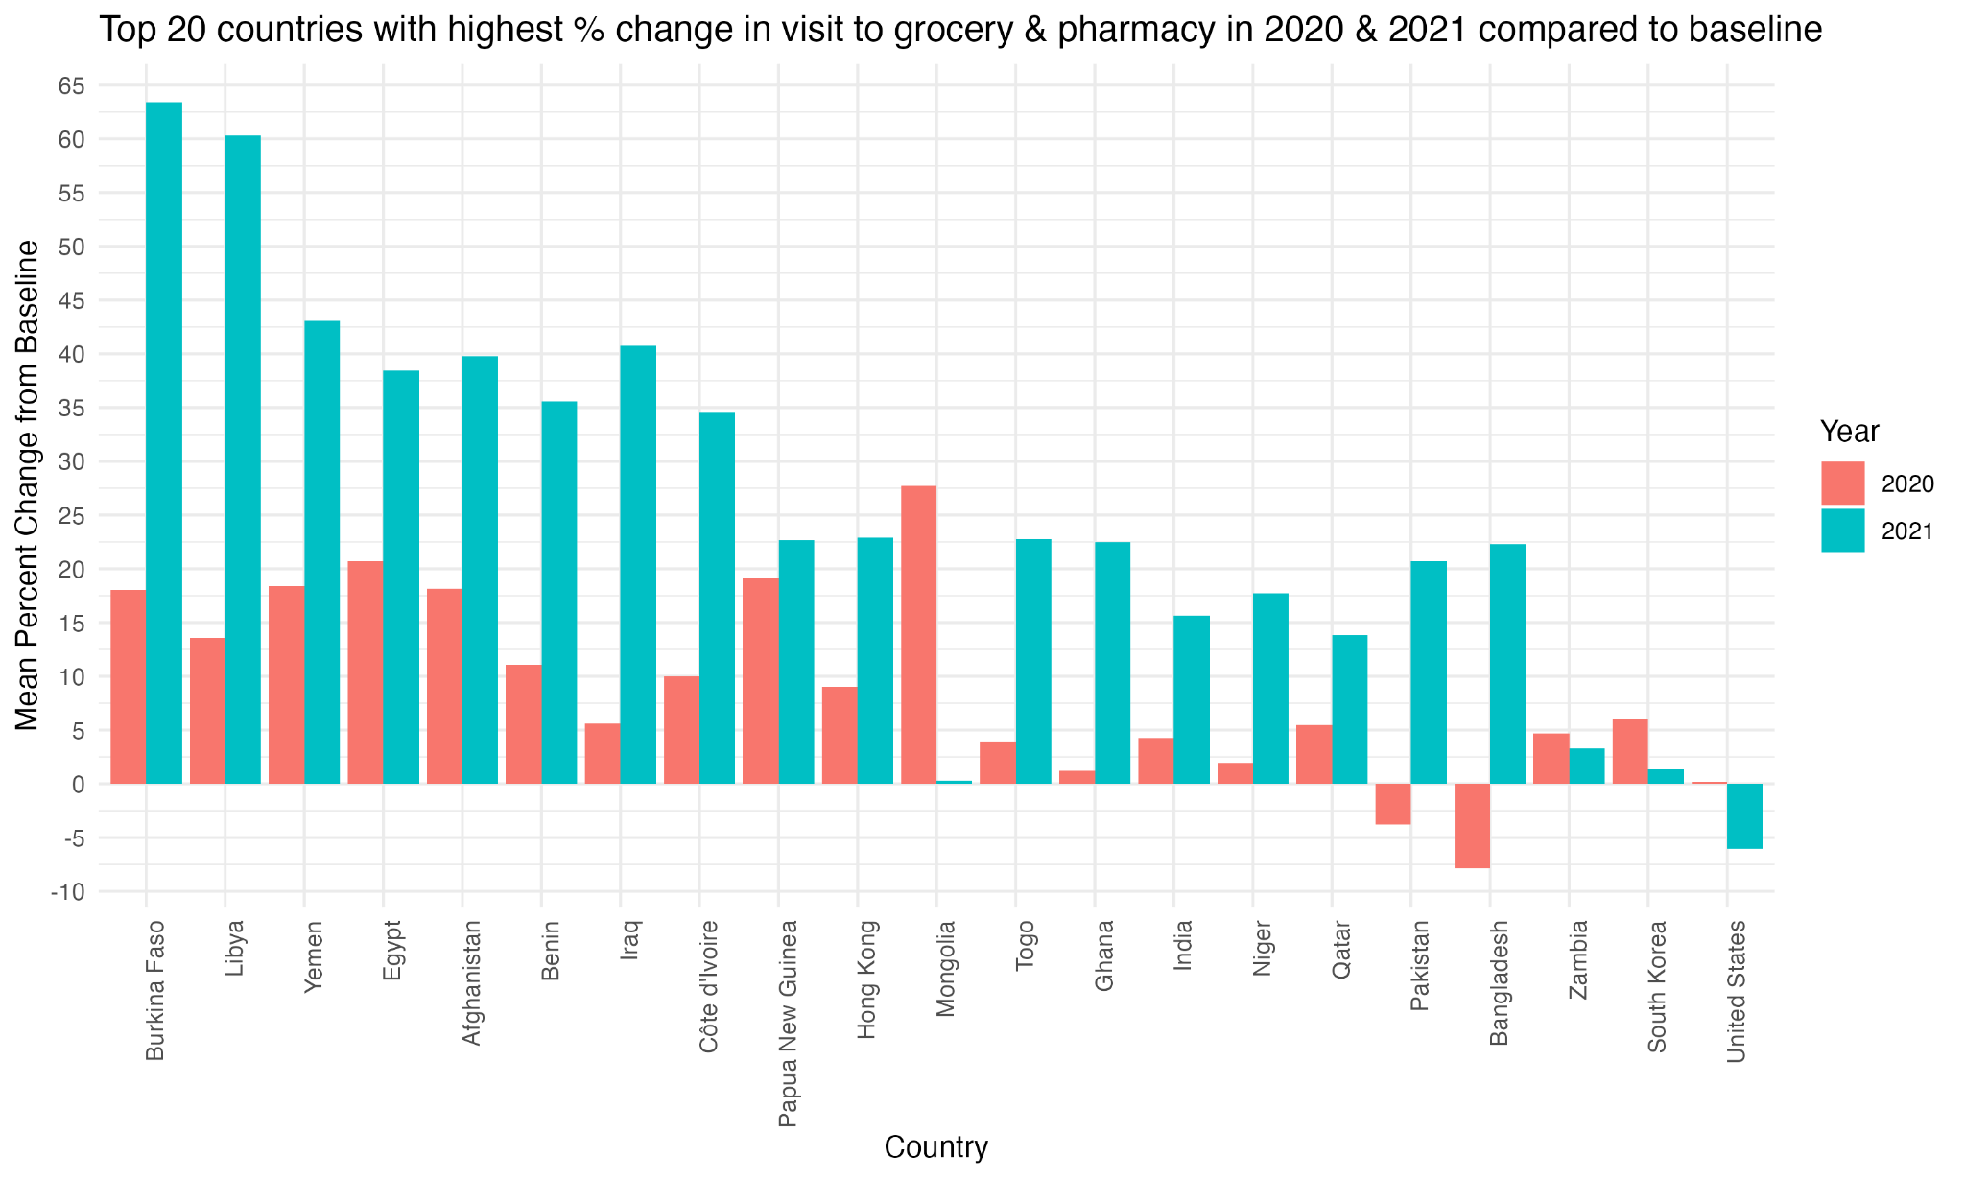

The above chart shows 20 countries (with addition of the United States) that have the highest change (percentage) in the public visits to grocery and pharmacy locations for 2020 and 2021 from the baseline. Compared to the public visits to retail and recreational locations, we can see that the people visited more grocery and pharmacy locations in these countries for both years. This does make sense since the locations such as grocery stores are a more essential part of people's lives than the retail or recreational locations. It also makes sense that the people visited pharmacies more than the retail or recreational locations. It’s clear that the people visited these locations more in 2021 compared to 2020 which indicates that the policies were more relaxed in 2021. It’s interesting to see that the people in the United States made fewer visits to these locations in 2021 than in 2020. It could be due to late response to the pandemic compared to other countries. It could also mean that the United States policies did not relax or made more stringent in 2021. It could also mean that the people were being treated more quickly than other countries which reduced the number of visits to pharmacies. On the other hand, the visits to these locations in Bangladesh and Pakistan were lower in 2020 than in 2021 indicating that the people there perhaps reacted slower to the pandemic than the other countries. Additionally, we can see that the people in Mongolia visited these locations the most amongst all other 20 countries right after the pandemic started (i.e. 2020). This number decreased significantly, from 27% to 1%, for Mongolia in 2021. Overall, this chart gives us a sense of people's visits to grocery stores and pharmacies in these countries between 2020 and 2021 in response to the policies imposed by the respective government officials.

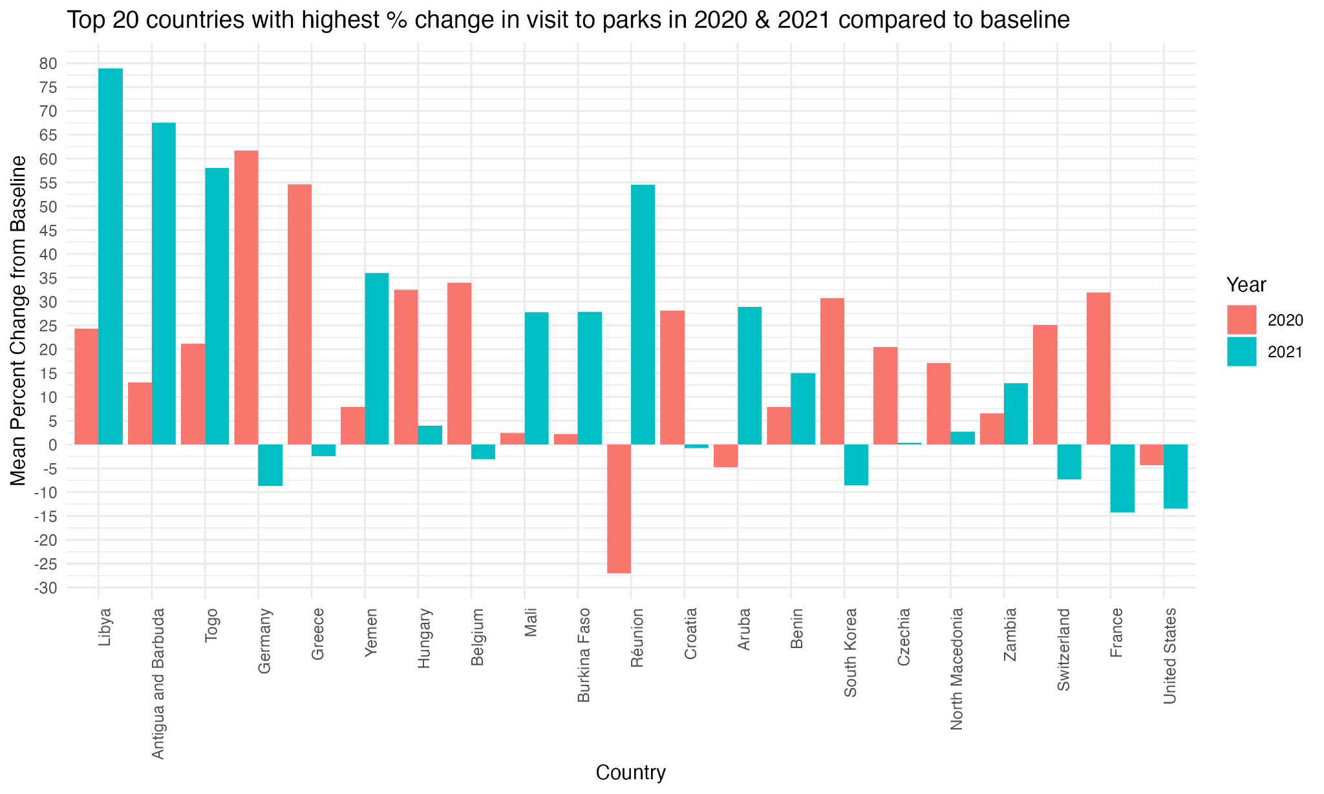

The chart above shows the percentage change in the number of public visits to the parks in the top 20 countries (in addition to the United States) between 2020 and 2021. Similar to the observations made on the previous chart (visits to grocery stores and pharmacies), we can see that the people in most of these countries were still making high visits to the parks in both years. In the year 2020, people in Reunion were making the least number of visits to the parks. But that number increased dramatically in 2021 indicating that either the pandemic policies were relaxed or the public started to cope with the pandemic. It is insightful to see that the people in Germany, France, Switzerland, South Korea, Belgium, and Greece visited the parks more in 2020 than in 2021. There could be several reasons for such behavior. Interestingly, the people in the United States visited the parks less in both years even though they visited the parks lesser in 2021.

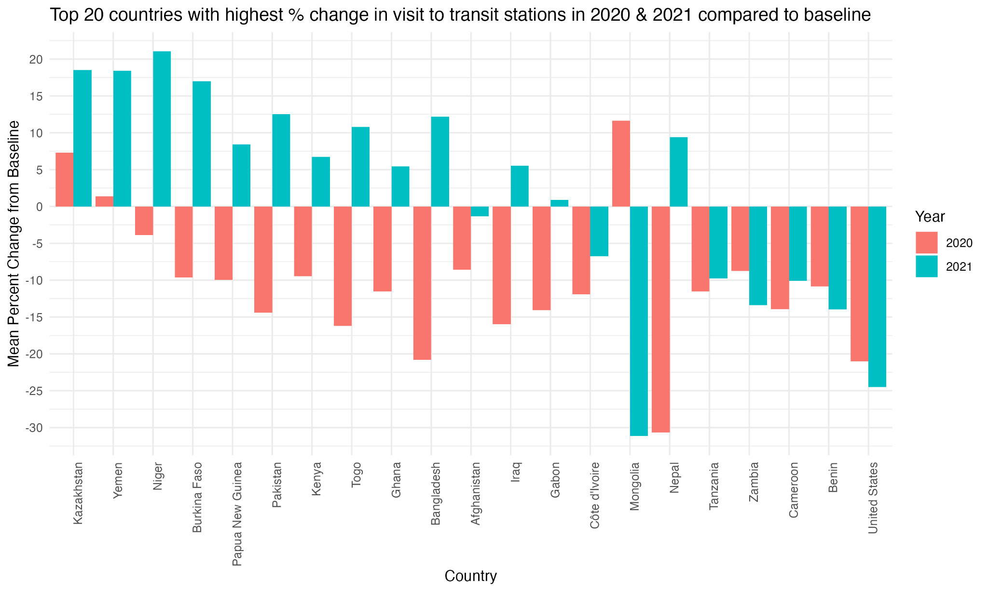

The graph above shows the average change in the number of public visits to public transit stations for the top 20 countries (in addition to the United States) in 2020 and 2021 when compared to the baseline. Similar to what we saw in the graph showing the public visits to the retail and recreational locations, we can see that the people in the majority of the countries visited the transit stations less in 2020. Only the people in Mongolia, Kazakhstan, and Yemen still visited these locations more than the baseline. Similar to previous reasoning, this behavior could be due the respective government policies not being strict enough or the people could have simply ignored those policies. Again, it is interesting to see that the people in Mongolia visited these locations more in 2021 than in 2020. On the contrary, the people in Nepal made significantly less visits to these locations in 2020, and there was slight recovery seen in 2021. On the other hand, the people in the USA still made less visits to these locations in both years. In fact, they visited these locations even less in 2021 as compared to 2020. This indicates that the government restriction policies made the people make less visits to these public transit locations.

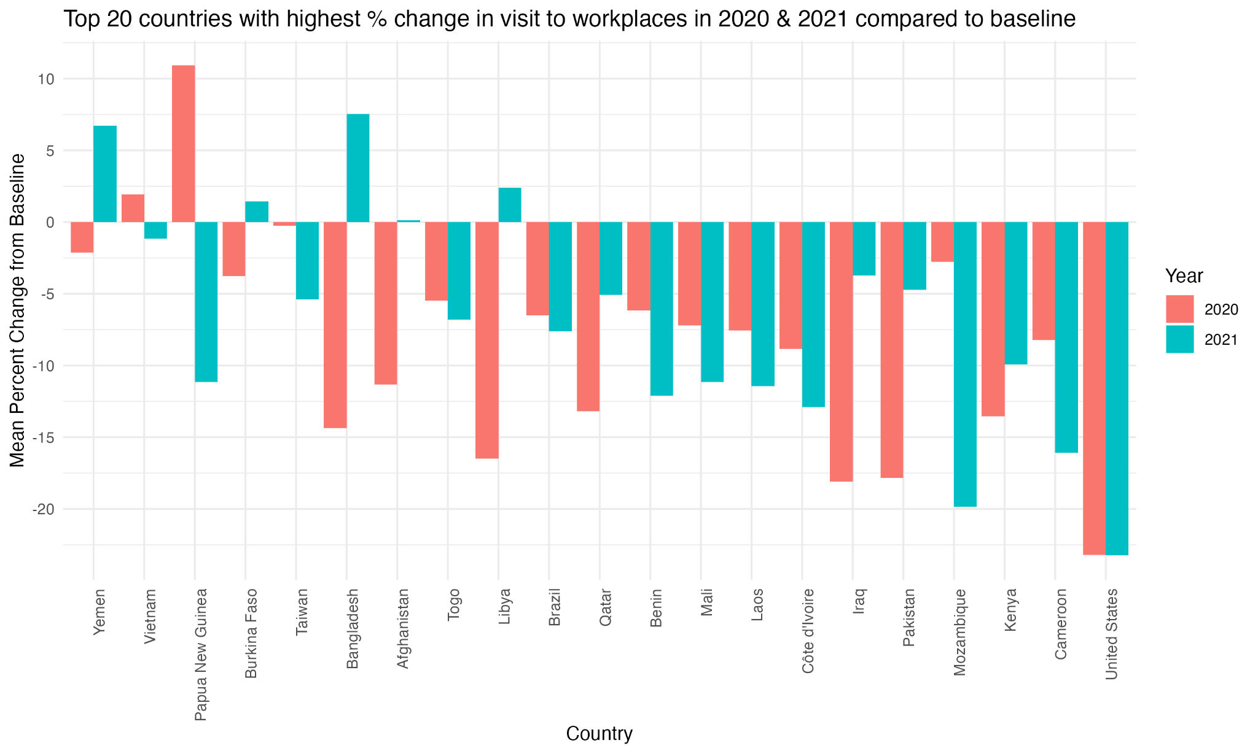

The above graph shows the percentage change of public visits to workplaces in top 20 countries (including USA) for 2020 and 2021 when compared to the baseline. Except for Papua New Guinea, the people in the rest of the other countries made fewer visits to workplaces in both years. It seems like the restriction policies in Papua New Guinea only started to show impact in 2021 as there is negative change in the visits to the workplaces in 2021. It is interesting to see that the people in Bangladesh started going to workplaces more in 2021 than in 2020. It is also interesting to see that the trend remained the same for the USA as the percentage change is almost the same for both years for the USA. This could indicate that the restriction policies remained unchanged from 2020 to 2021 in the USA. All the remaining 20 countries had the people went to workplaces more or less in 2021 compared to 2020.

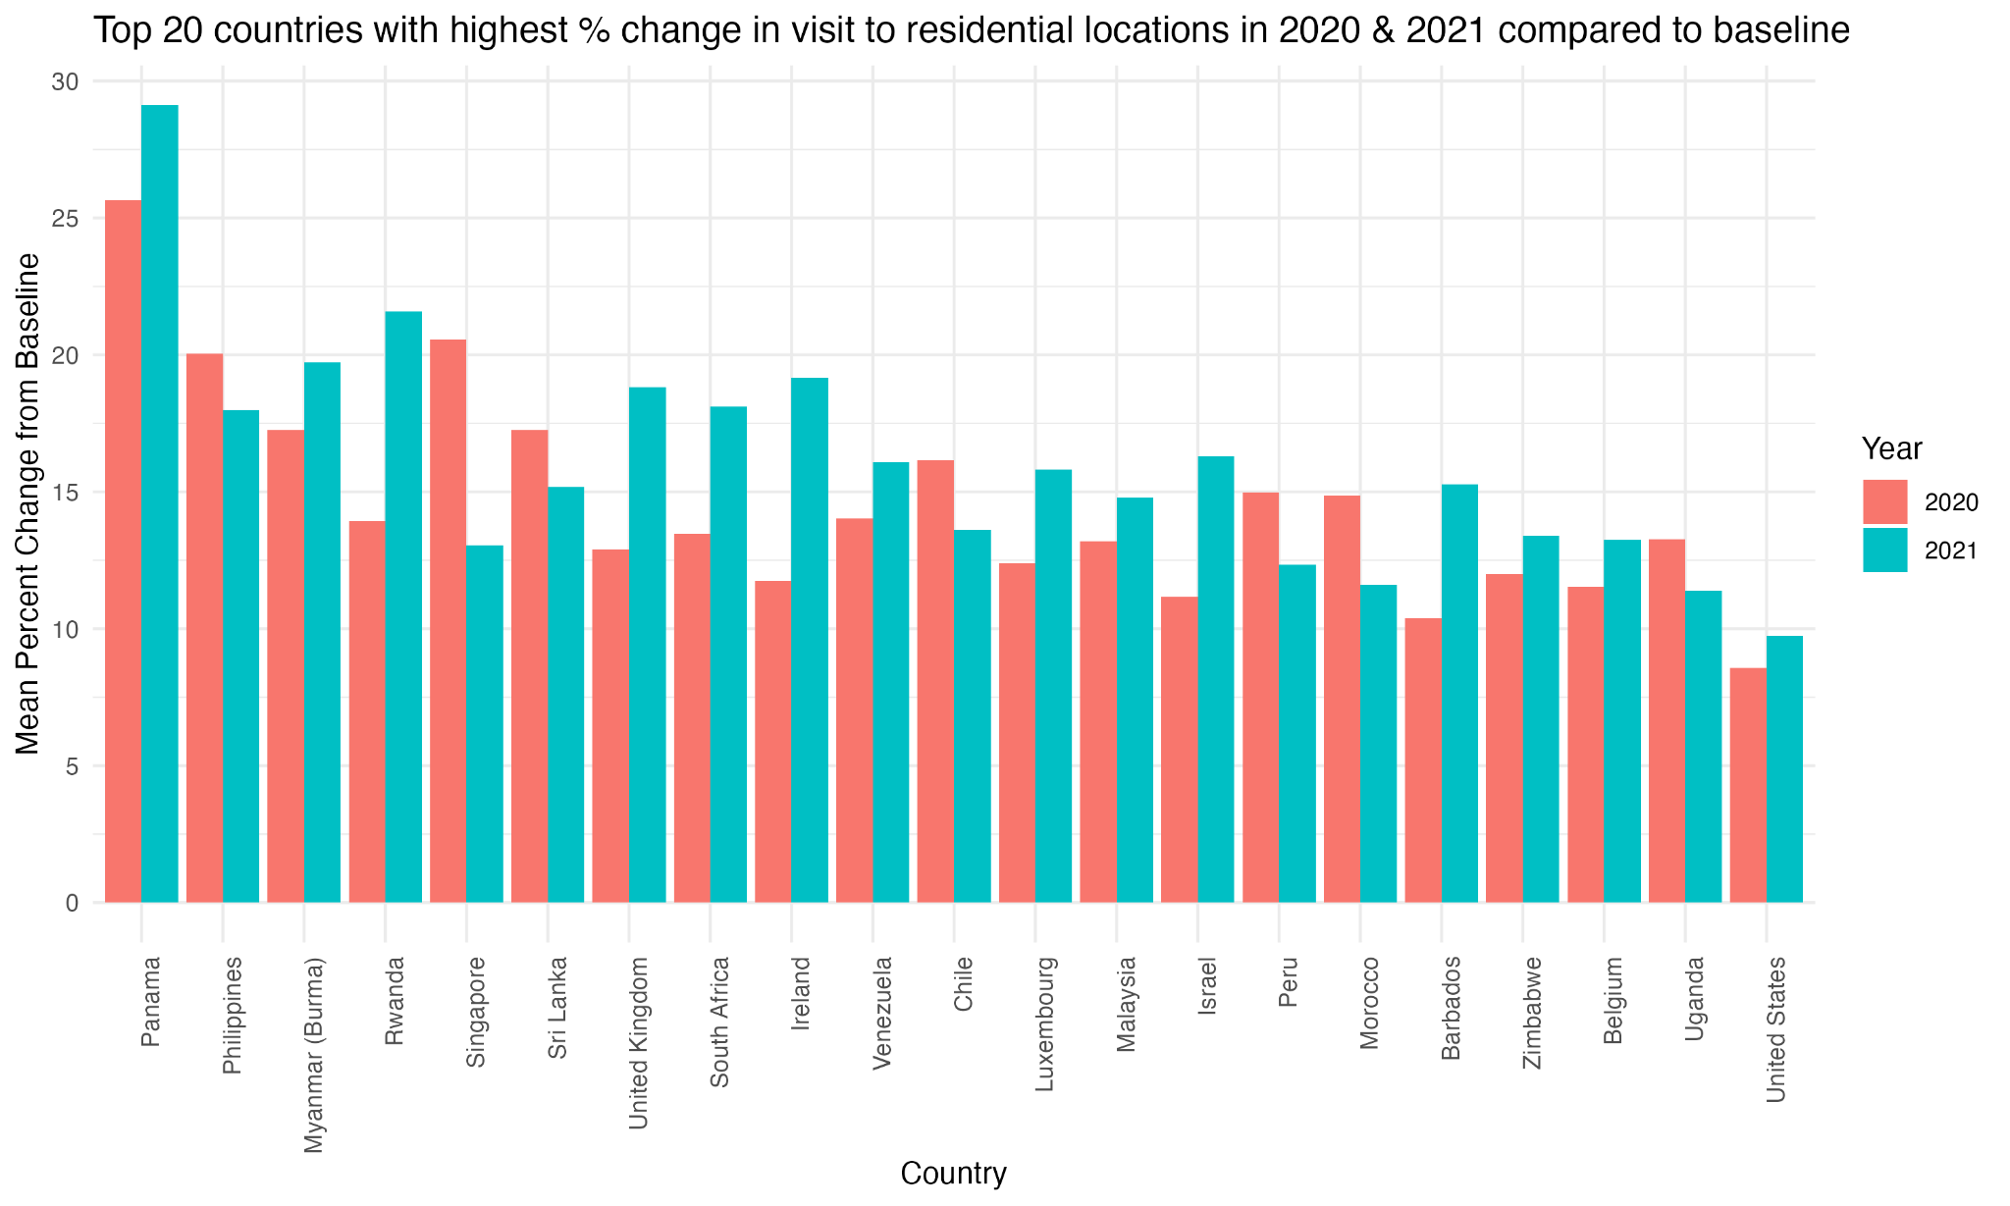

The above chart shows the percentage change in people staying home for the top 20 countries (in addition to the USA) in 2020 and 2021 when compared to the baseline. As expected, people were staying home more after the pandemic started all around the world. Out of these 21 countries, the people in 13 countries are staying home more in 2021 than in 2020. This indicates that the restrictions were not relaxed or remained effective to keep the people at their residential locations in 2021 too. This observation applies to the people in the USA too.

​​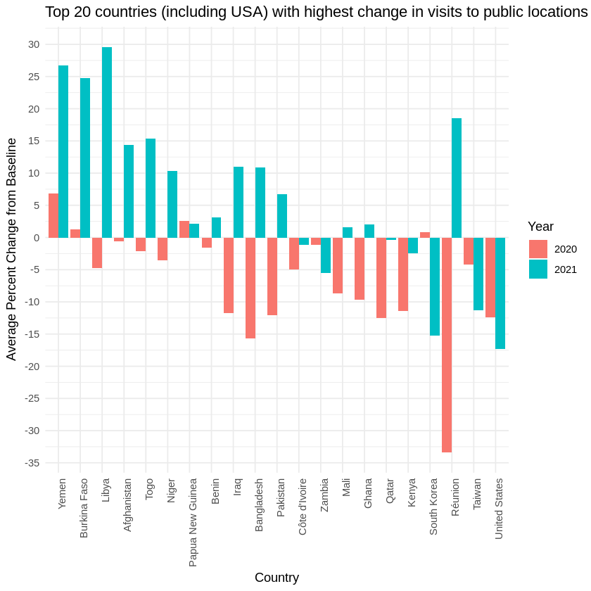

The above chart shows the average change of public visits to the public locations described in the previous charts in top 20 countries (including USA) for 2020 and 2021 when compared to the baseline. As predicted, we can see that the majority of these countries saw less visits to these locations in 2020, and saw some recovery in 2021. We can see that there were still fewer visits to these locations even in 2021 in the USA , supporting the previous observations on individual public locations previously.

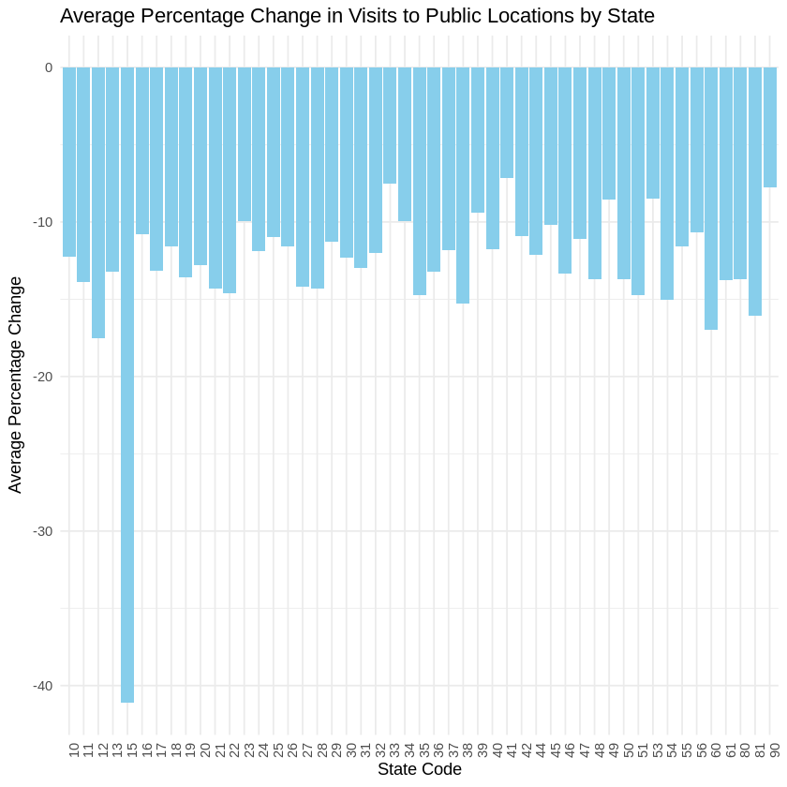

This chart shows the % average change in public visits to public locations (2020 and 2021 combined) for all US states. We can see that the state 15 (i.e. Hawaii) saw the highest change in such visits compared to the rest of the states. Looking at statistics for Texas (code 48), we can see that the average % change is about -13%. See the appendix “State Level Fips Code” for the state fips codes.

**---------------------------------------Abhilash start------------------------------------------------------------------------------**

## **Dataset 2: COVID-19_cases_TX.csv**

The below activities were performed to clean the data set and add additional features.

1. Removing the observations that were not tagged to a county
2. Correcting the datatype of the date fields.
3. Adding a new feature – Death Percentage – which is death/confirmed cases

tx_covid_cases <- **subset**(tx_covid_cases,county_name **!=**'Statewide Unallocated')   
tx_covid_cases**$**date <- **as.Date**(tx_covid_cases**$**date,format = "%Y-%m-%d")  
**options**(max.print=10)  
tx_covid_cases

## county_fips_code county_name state state_fips_code date  
## 371 48001 Anderson County TX 48 2020-01-22  
## confirmed_cases deaths  
## 371 0 0  
## [ reached 'max' / getOption("max.print") -- omitted 93979 rows ]

Summary of the COVID cases and Death by County

tx_covid_cases_county = tx_covid_cases **%>%** **group_by**(county_name) **%>%**  
 **summarise**(total_confirmed_cases = **sum**(confirmed_cases),   
 total_deaths = **sum**(deaths),   
 .groups = 'drop')  
tx_covid_cases_county**$**death_perc=tx_covid_cases_county**$**total_deaths**\***100**/**tx_covid_cases_county**$**total_confirmed_cases   
tx_covid_cases_county <- tx_covid_cases_county[**order**(tx_covid_cases_county**$**death_perc,  
 decreasing = TRUE), ]

### Death Percentages for each County

Death percentage is considered as “total deaths” divided by “ confirmed cases” . A low death percentage indicates that county was able to treat the confirmed cases better than other counties, And a high death percentage indicates that these counties had more death w.r.t the confirmed cases. We will later use other datasets to understand on why this can be.

The below graph shows the percentage of COVID deaths over Confirmed Cases

The below figures 2.1 and 2.2 shows Top 10 counties with the Highest and Lowest Death Percentages.

(Figure 2.1)

Figure 2.2

### Is there any relation between Death Percentage and Median Income?

The above graph clearly shows that the death percentage is clearly related to Median Income of the County. The Counties with the highest death Percentages are the counties with Lowest Median income. For example Kenedy County has the highest death percentage(>10%) and is one of the counties with the lowest Median Income

References:-

<https://r.geocompx.org/adv-map>

<https://remiller1450.github.io/s230s19/Intro_maps.html>

**---------------------------------------Abhilash end------------------------------------------------------------------------------**

## **Dataset 3: COVID-19_cases_plus_Census.csv**

| **Attribute Name** | **Attribute Summary** |
| --- | --- |
| state | Length Class Mode  3142 character character |
| state_fips_code | Min. 1st Qu. Median Mean 3rd Qu. Max.  1.00 18.00 29.00 30.28 45.00 56.00 |
| county_name | Length Class Mode  3142 character character |
| confirmed_cases | Min. 1st Qu. Median Mean 3rd Qu. Max.  0.0 796.2 1916.5 7558.9 4955.0 1002614.0 |
| deaths | Min. 1st Qu. Median Mean 3rd Qu. Max.  0.0 12.0 31.0 124.8 77.0 13936.0 |
| median_age | Min. 1st Qu. Median Mean 3rd Qu. Max.  21.60 37.90 41.20 41.15 44.20 66.40 |
| total_pop | Min. 1st Qu. Median Mean 3rd Qu. Max.  74 10945 25692 102166 67445 10105722 |
| male_pop | Min. 1st Qu. Median Mean 3rd Qu. Max.  39 5514 12798 50292 33481 4979641 |
| female_pop | Min. 1st Qu. Median Mean 3rd Qu. Max.  35 5460 12885 51873 34108 5126081 |
| white_pop | Min. 1st Qu. Median Mean 3rd Qu. Max.  18 8093 20205 62787 53500 2676982 |
| black_pop | Min. 1st Qu. Median Mean 3rd Qu. Max.  0 95 758 12554 5396 1226134 |
| asian_pop | Min. 1st Qu. Median Mean 3rd Qu. Max.  0.0 31.0 138.0 5407.2 712.5 1442577.0 |
| hispanic_pop | Min. 1st Qu. Median Mean 3rd Qu. Max.  0 323 1025 17986 4868 4893579 |
| amerindian_pop | Min. 1st Qu. Median Mean 3rd Qu. Max.  0.0 24.0 95.5 668.0 348.0 64102.0 |
| other_race_pop | Min. 1st Qu. Median Mean 3rd Qu. Max.  0.0 24.0 95.5 668.0 348.0 64102.0 |
| median_income | Min. 1st Qu. Median Mean 3rd Qu. Max.  19264 41123 48066 49754 55764 129588 |
| income_less_50K | Min. 1st Qu. Median Mean 3rd Qu. Max.  9 2294 5339 16579 12832 1388992 |
| income_50K_100K | Min. 1st Qu. Median Mean 3rd Qu. Max.  19 1244 2971 11342 8038 927390 |
| income_100K_150K | Min. 1st Qu. Median Mean 3rd Qu. Max.  0.0 396.2 1017.5 5315.7 3134.0 477403.0 |
| income_150K_more | Min. 1st Qu. Median Mean 3rd Qu. Max.  0.0 183.0 483.5 4582.0 1756.5 501413.0 |
| rent_under_50_percent | Min. 1st Qu. Median Mean 3rd Qu. Max.  6.0 685.2 1751.5 9429.8 5166.8 1160618.0 |
| rent_over_50_percent | Min. 1st Qu. Median Mean 3rd Qu. Max.  0 162 486 3237 1576 536832 |
| median_age | Min. 1st Qu. Median Mean 3rd Qu. Max.  21.60 37.90 41.20 41.15 44.20 66.40 |
| male_0_20 | Min. 1st Qu. Median Mean 3rd Qu. Max.  1 1476 3524 14139 9245 1378157 |
| male_21_49 | Min. 1st Qu. Median Mean 3rd Qu. Max.  10 1900 4604 19741 12309 2161991 |
| male_50_above | Min. 1st Qu. Median Mean 3rd Qu. Max.  25 2312 5163 17760 13163 1544545 |
| female_0_20 | Min. 1st Qu. Median Mean 3rd Qu. Max.  4 1363 3277 13514 8837 1322003 |
| female_21_49 | Min. 1st Qu. Median Mean 3rd Qu. Max.  8 1737 4334 19567 11846 2131518 |
| female_50_above | Min. 1st Qu. Median Mean 3rd Qu. Max.  23 2452 5710 20243 14641 1795247 |
| unemployed_pop | Min. 1st Qu. Median Mean 3rd Qu. Max.  0.0 286.2 745.5 3361.0 2099.8 406426.0 |
| employed_pop | Min. 1st Qu. Median Mean 3rd Qu. Max.  39 4550 10695 47931 29515 4805817 |
| commute | Min. 1st Qu. Median Mean 3rd Qu. Max.  140 15410 36238 154635 98145 15285110 |
| walked_to_work | Min. 1st Qu. Median Mean 3rd Qu. Max.  0.0 98.0 242.5 1288.8 678.5 181289.0 |
| walked_to_work | Min. 1st Qu. Median Mean 3rd Qu. Max.  0.0 98.0 242.5 1288.8 678.5 181289.0 |

Table: Summary of the attributes in the final “COVID-19_cases_plus_census” dataset

**Feature Processing**

The table above shows the statistics of the dataset with only 29 variables that were left after removing irrelevant or less significant variables and adding new variables. Following is brief details on some of the variables:

* state : contains two letters code for the states, 51 unique codes, data type is character
* state_fips_code: contains two digits fips code for the states, 51 unique fips codes, data type is integers
* county_name: contains the names of the US counties, 1878 unique county names, data type is character
* confirmed_cases: contains the number of confirmed cases per geographic region, the maximum confirmed cases is 1002614, data type of integers
* total_pop: contains total population in a geographic region, the range of total population range from 74 to 10105722, data type of numeric

Upon further inspecting each variable, there were no missing values found in the entire dataset. Also, each of the variables only contained only one type of data (i.e. numeric or character or integers).

**Data Analysis**

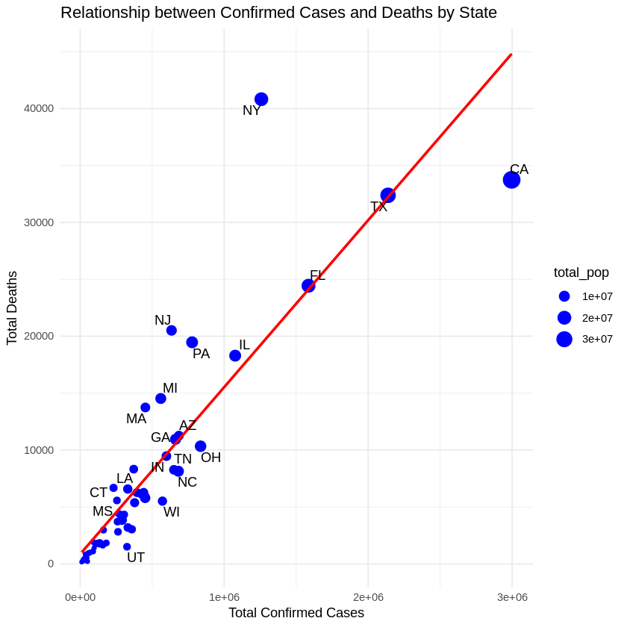

Figure: Relationship between confirmed cases, deaths, and state

The chart above shows the relationship between the number of confirmed cases of COVID-19 and the number of the deaths for the US states. The analysis only includes the death cases that are 1000 or more. The size of the bubbles represent the size of the state's total population. We can see that there is a linear relationship between the number of the confirmed cases and the number of the deaths. For example, it’s clear that this relationship is very strong for Florida (FL) and Texas (TX). We can also see that the states with higher population saw a higher number of confirmed cases. One interesting observation is that California (CA), with a higher population and number of confirmed cases than New York (NY), still saw a lower number of deaths than NY. There is somewhat similar behavior that can be seen with Pennsylvania (PA) and New Jersey “NJ”. Both of these states have similar population sizes but there were fewer confirmed cases in PA than in NJ. However, there were slightly more deaths in NJ. There could be many possible reasons behind such behavior.

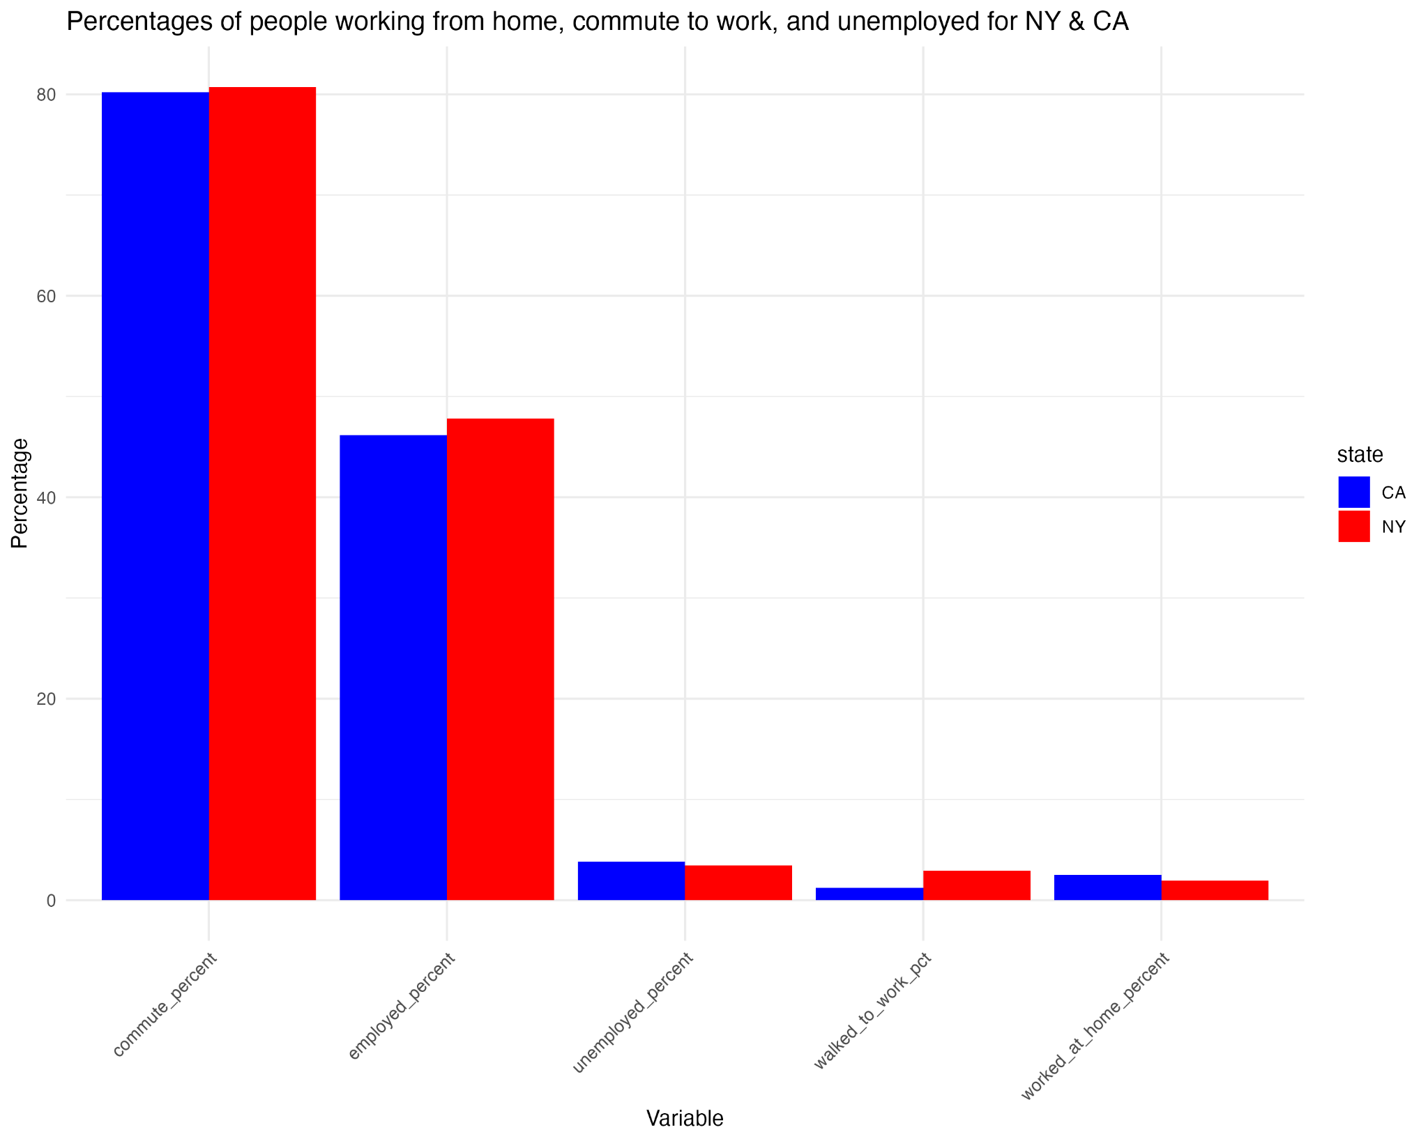

Fig: Percentages of population commuting to work, worked from and unemployed (NY & CA)

The above bar chart shows the comparison between the percentages of the people commuting to work, unemployed, and working from home between CA and NY. We can see that more people were commuting to work and were employed in NY than in CA during the pandemic. At the same time, there were more people who were unemployed and worked from home in CA than in NY during the pandemic. This could be the reason we saw that there were higher number of deaths in NY than in CA even though CA’s population is slightly bigger than that of NY.

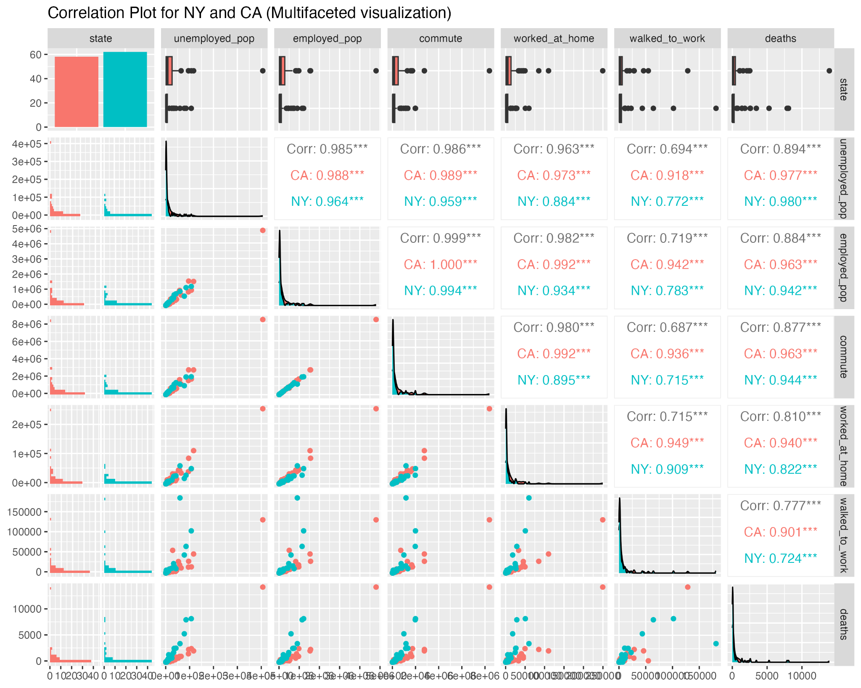

Fig: Correlation plot (Multifaceted Visualization)

The above multifaceted chart shows correlation between different variables for CA and NY. For all of the variables (with an exception with the variable “unemployed_pop”), we can see that the correlation between those variables with the “deaths” variable is comparatively higher for CA than that of NY. The difference between the correlation between these two states is even higher for the variables that have data for the public commuting to work. For example, the correlation between the number of deaths and the number of people commuting to work is slightly higher for CA than NY (CA: 0.963 and NY: 0.944). But this difference between the correlation values is even higher if we consider the correlation value between the number of deaths and the number of people that walked to work (CA: 0.901 and NY: 0.724). So we can say that there is a stronger correlation between the number of deaths and the number of people commuting to work in CA than NY. This observation is supported by the observation made in the scatter plot that showed the relationship between confirmed cases and deaths for various states. In the scatter plot, we see that CA lies below the mean (i.e. regression line) while NY lies above the mean. Nevertheless, there is a strong direct correlation between the number of deaths and the number of people commuting to work or employed. This direct correlation is slightly weaker when the number of deaths is compared to the number of people unemployed or working from home.

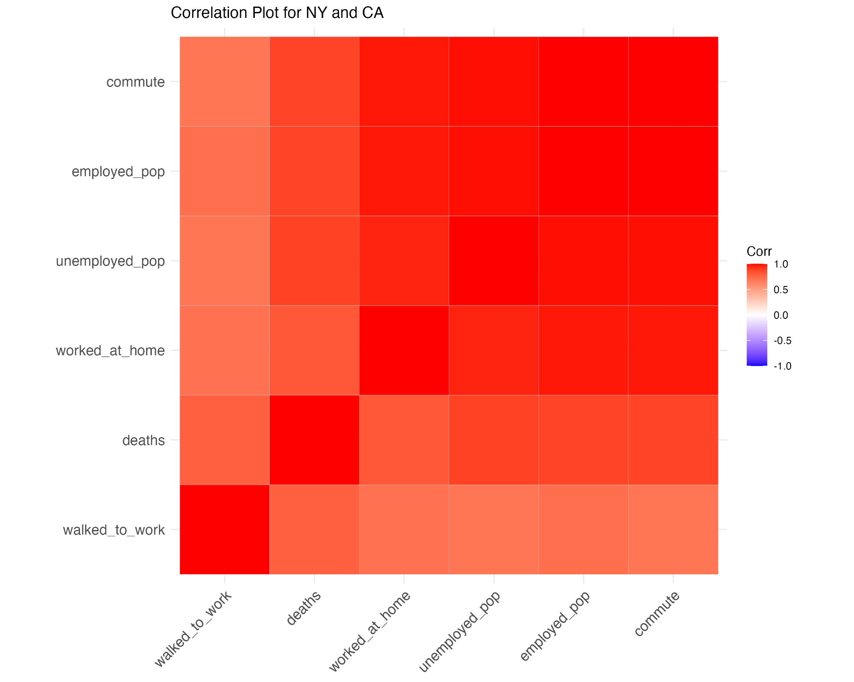

Fig: Correlation matrix plot between NY and CA

The above shows the correlation matrix plot between the same variables for NY and CA. As seen before, we can further validate that there is a stronger direct correlation between the number of deaths and the number of people commuting to work or employed when compared to the relationship between the number of deaths and the number of people working from home or unemployed.

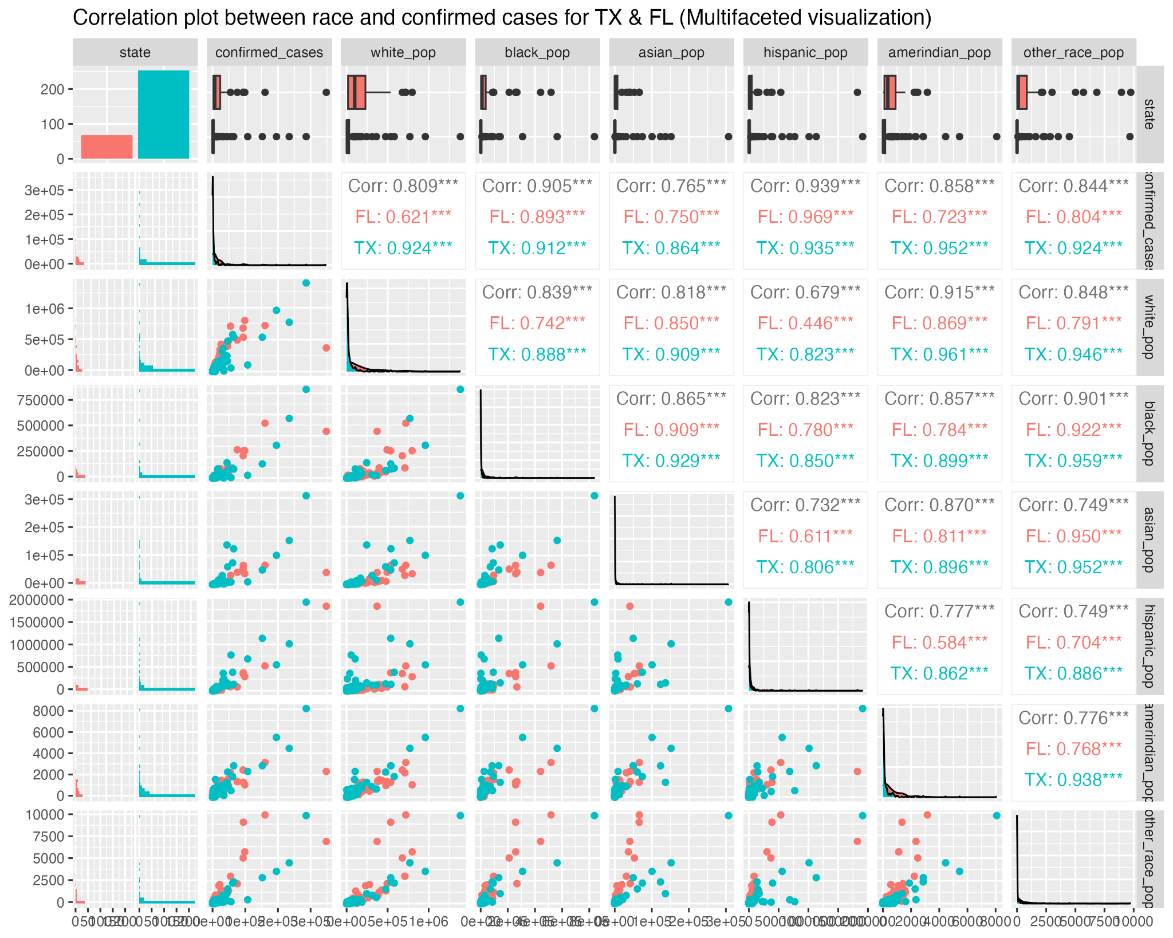

Fig: Correlation plot between different race and confirmed cases (TX & FL)

The above correlation plot shows the correlation between the number of confirmed cases and various types of race. We are considering only Texas (TX) and Florida (FL) because these two states lie in the mean (i.e. regression line) of the correlation between the number of deaths and confirmed cases for various states. So further analysis on these two states could provide meaningful insights on the relationship between confirmed cases or deaths to several factors of our society. From the above correlation plot, we can see that there is a slightly stronger correlation between all non-white races and the number of confirmed cases for Florida. This means that the people in Florida saw fewer confirmed cases if they were of white race. The people belonging to asian and amerindian races also seem to have fewer number of confirmed cases. However, fewer asian people had confirmed cases in Texas. But if we compare the correlation between Texas and Florida, it looks like every other race other than the hispanic in Texas has a stronger correlation. The correlation of FL is 0.969 while TX has correlation of 0.935 for hispanic race. This could be because the majority of the population in FL is hispanic or there could be other reasons such as financial structure.

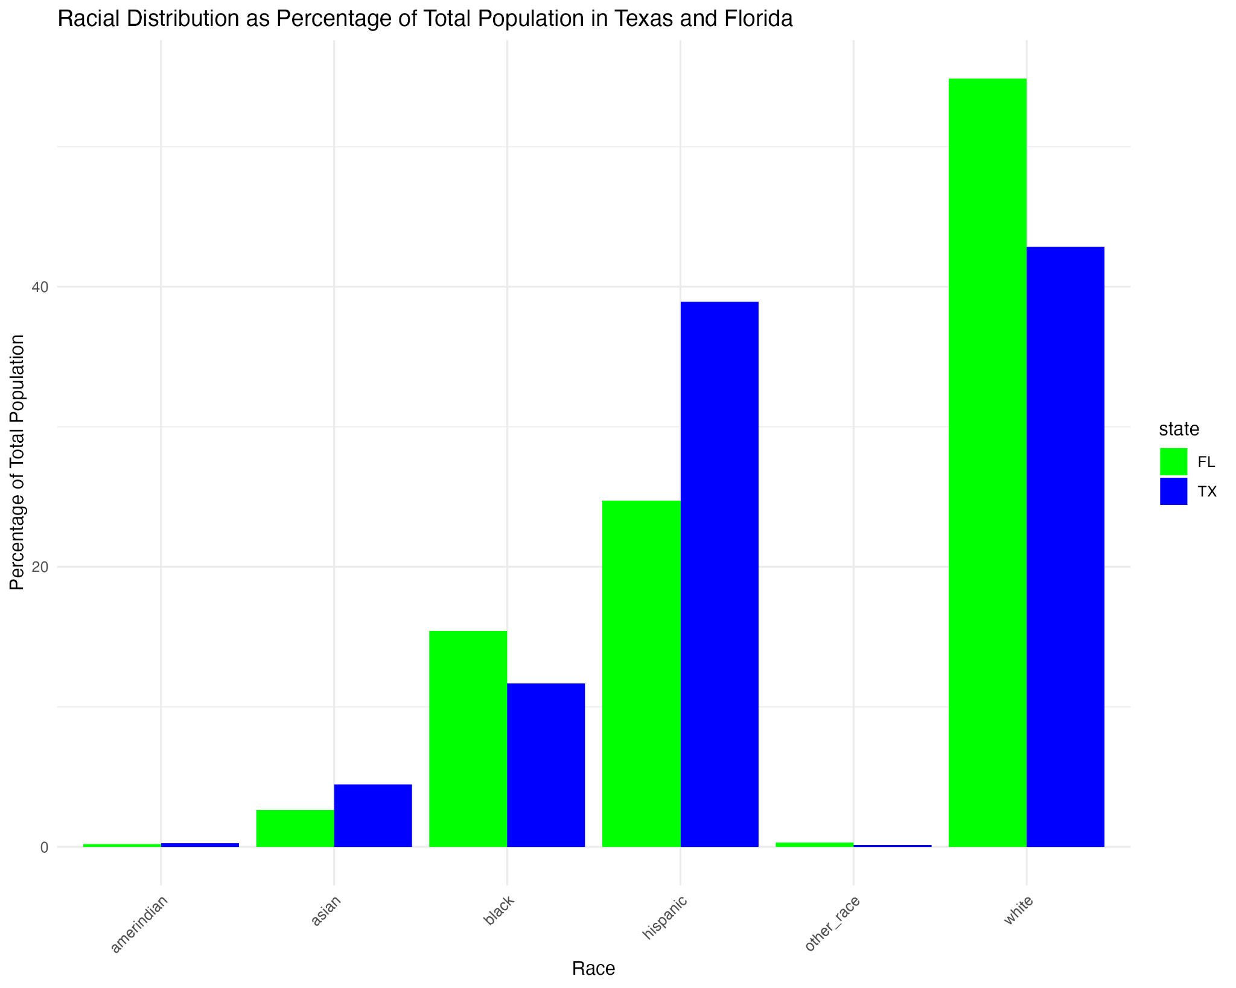

Fig: Race proportion in TX and FL

From the bar chart above, we can see that the majority of the people are white and hispanic in Texas than in Florida. But still we saw that the correlation between white or hispanic to the number of confirmed cases is lowest in Florida when compared to Texas. This indicates that the distribution of the population based on race is not a contributing factor for confirmed cases. Unfortunately, the answer to the question why the hispanic population showed more number of confirmed cases in FL than in TX cannot be answered solely from the dataset. For example, there is information on the number of people with various income levels which could be one of the many reasons. However, the information on the number of certain races making a certain income level cannot be retrieved from the dataset. Rather the dataset can only say the proportion of the population making a certain income for a state.

Note: the correlation between death cases and various races is provided in the “DataMining_Project1_plus_census” file.

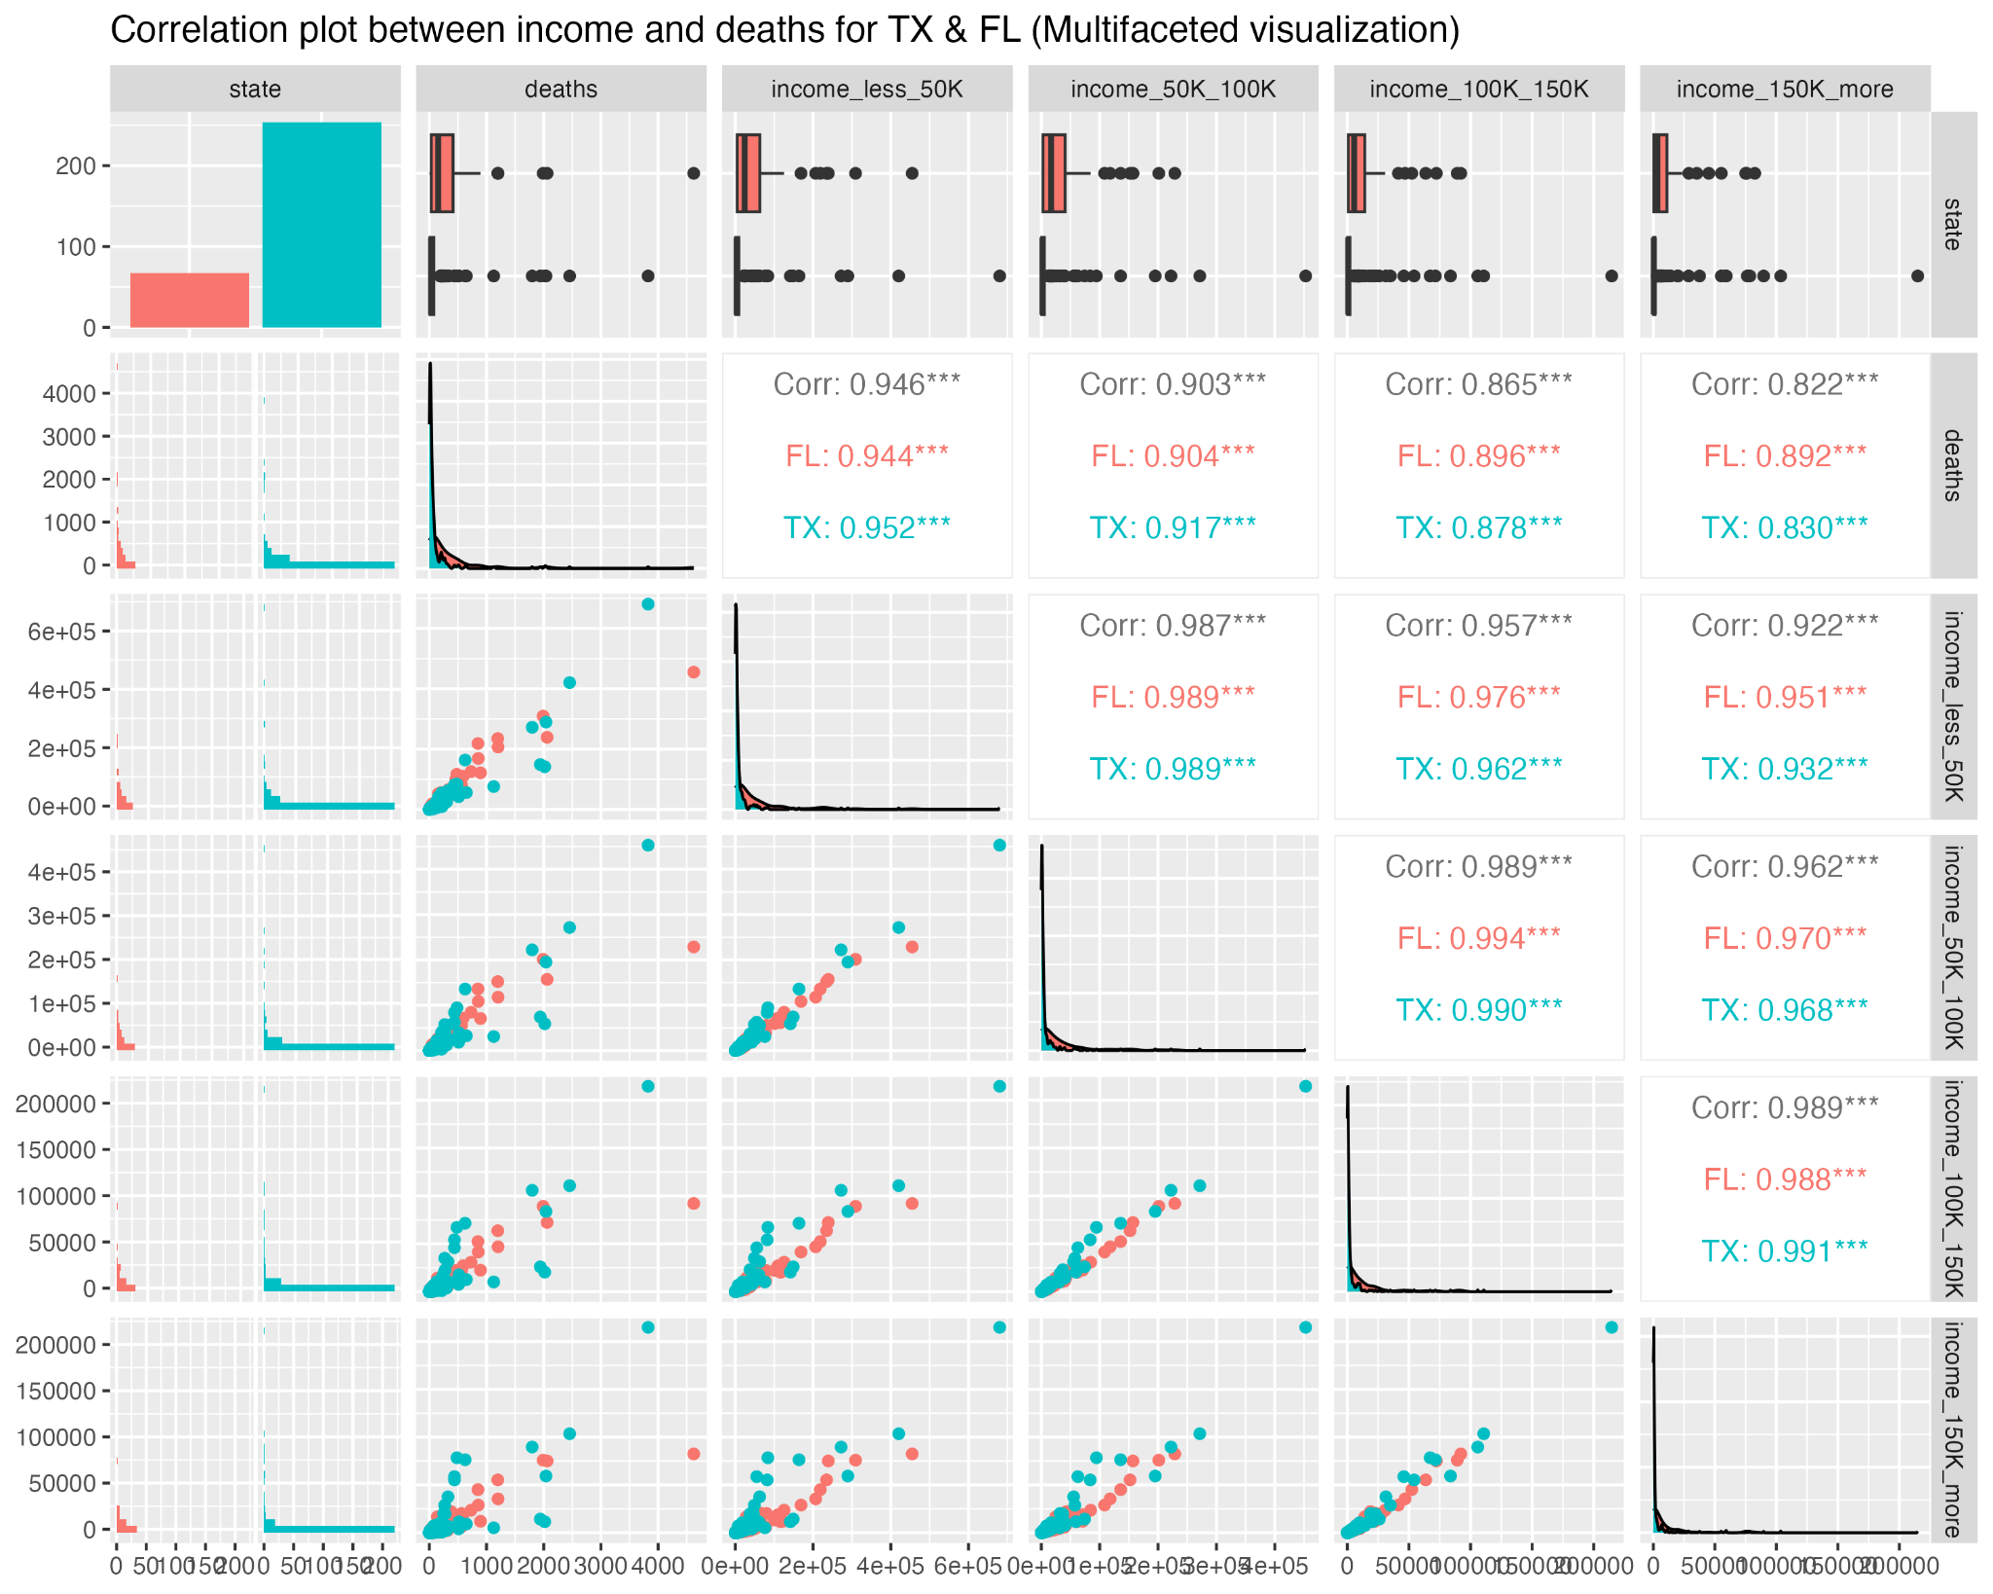

Fig: Correlation between deaths and income level (TX & FL)

The above multifaceted correlation plot shows correlation between various income levels and the death cases for Texas and Florida. Regardless of the size of the population, we can see that there were fewer deaths in the population with higher incomes. The people making less than 50K per year died more during the pandemic. The same observation is true for the confirmed cases (plot shown in “DataMining_Project1_plus_census” file).

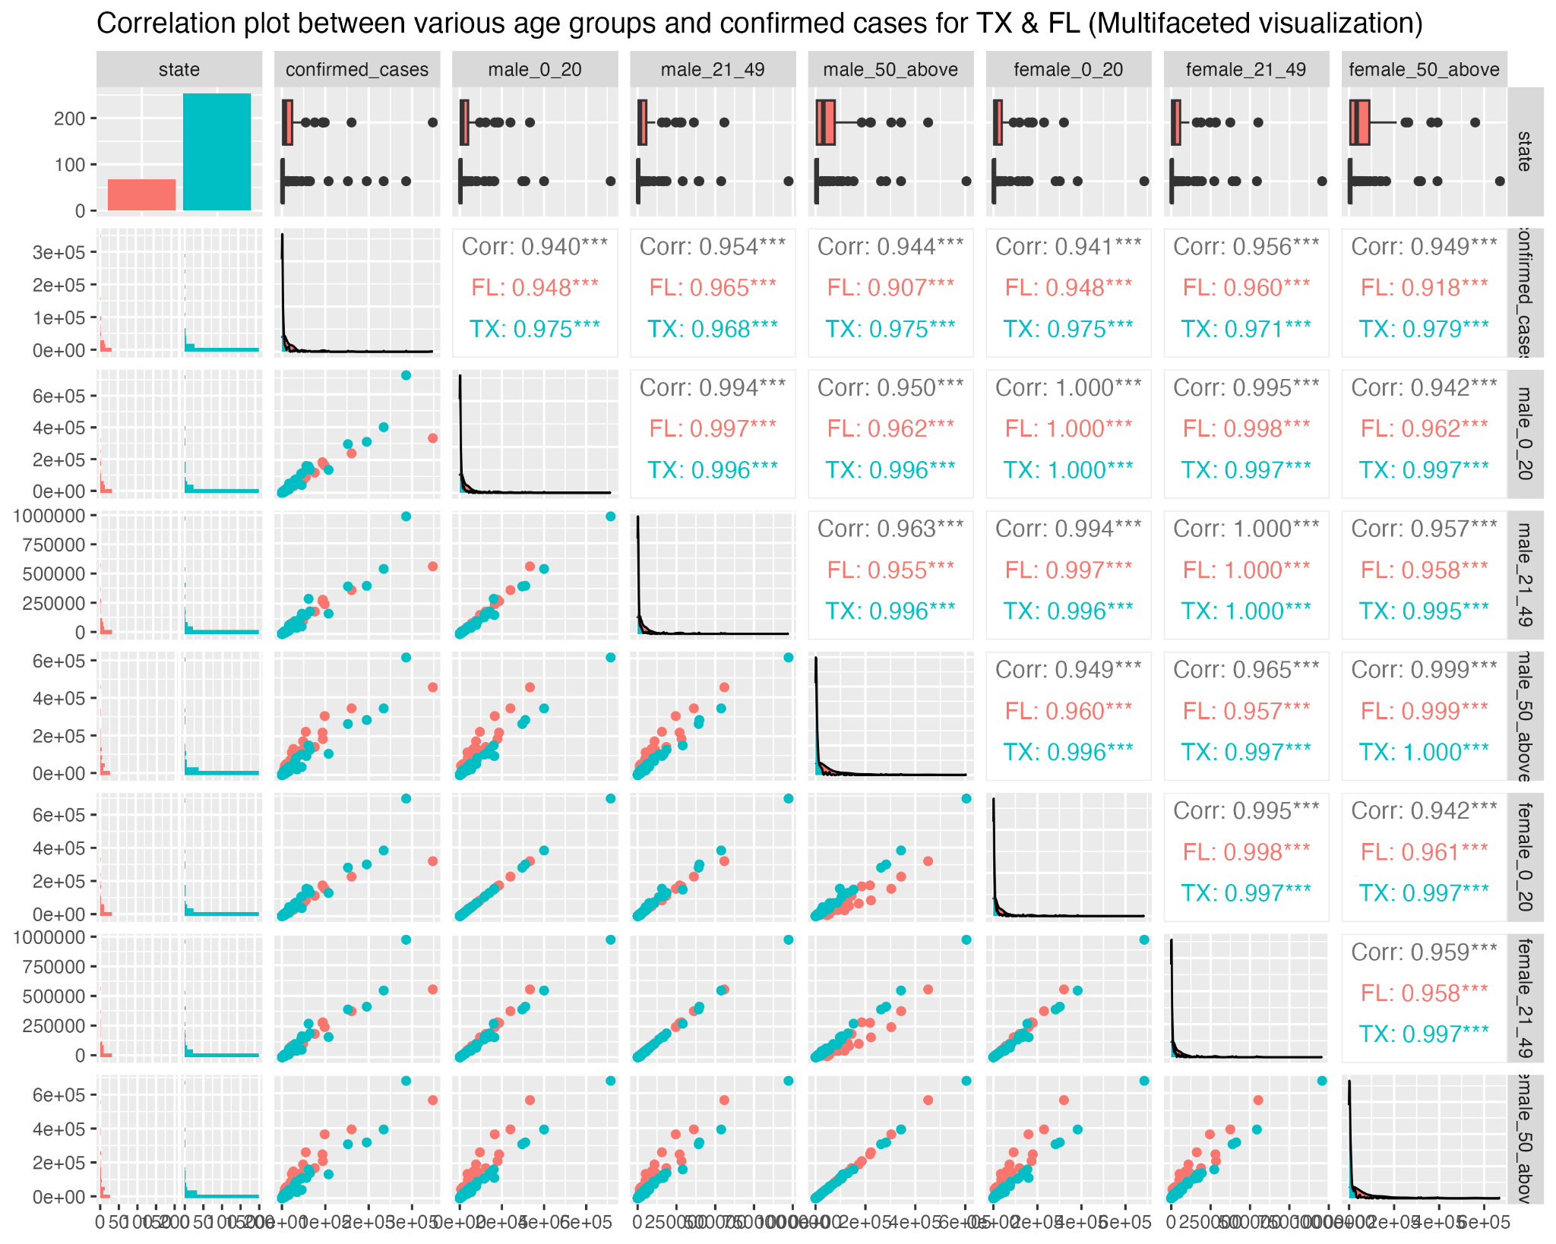

Fig: Correlation between age and confirmed cases

In the above correlation plot, we can see correlation between various age groups (males and females) and confirmed cases for TX and FL. In Florida, the strongest correlation exists for both males and females aged between 21-49. But in Texas, the strongest correlation exists for males aged between 0-20 or 50-above and females aged 50-above. The correlation values for aged 0-20 and 50-above are exactly the same but this could be due to rounding. Using the statistics on the proportion of each age group for males in Florida, we can validate the age group with the strongest correlation for the males in Florida.

Note: the correlation between deaths and various age groups is in the “DataMining_Project1_plus_census” file

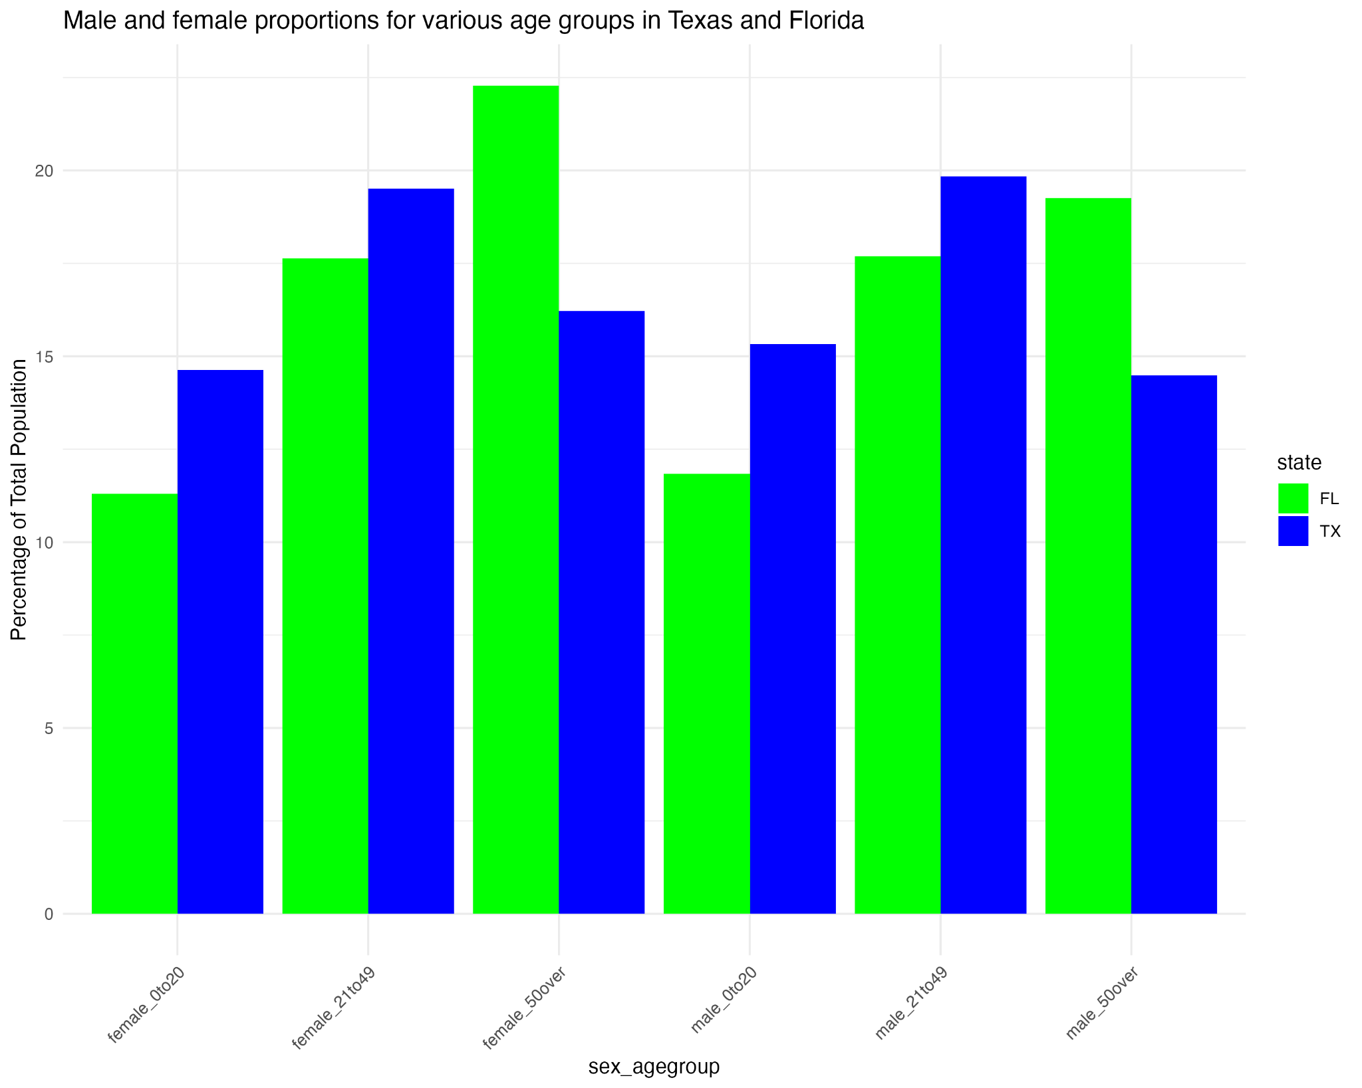

Fig: Proportion of various age groups (males & females) in TX and FL

Shown above is the histogram for various age groups for males and females in Texas and Florida. We can see that there are more males and females aged between 21 and 49 in Texas. Therefore, we previously saw the strongest correlation for this age group in Texas. Similarly, we can see that there are more males and females aged 50 and over in Florida. This is why we saw the strongest correlation for this age group in Florida.

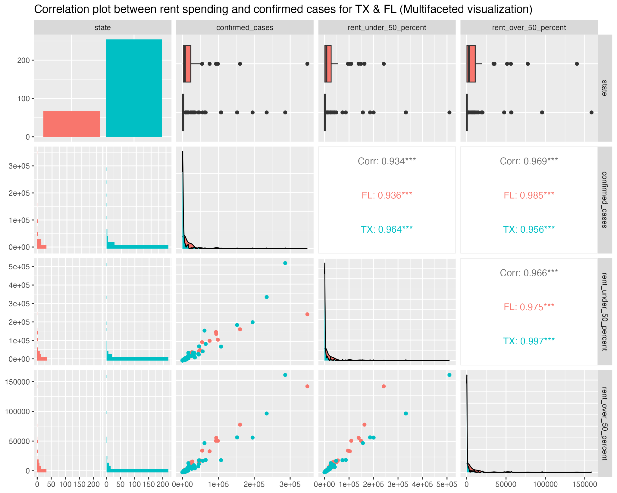

Fig: Correlation between rent spending and confirmed cases

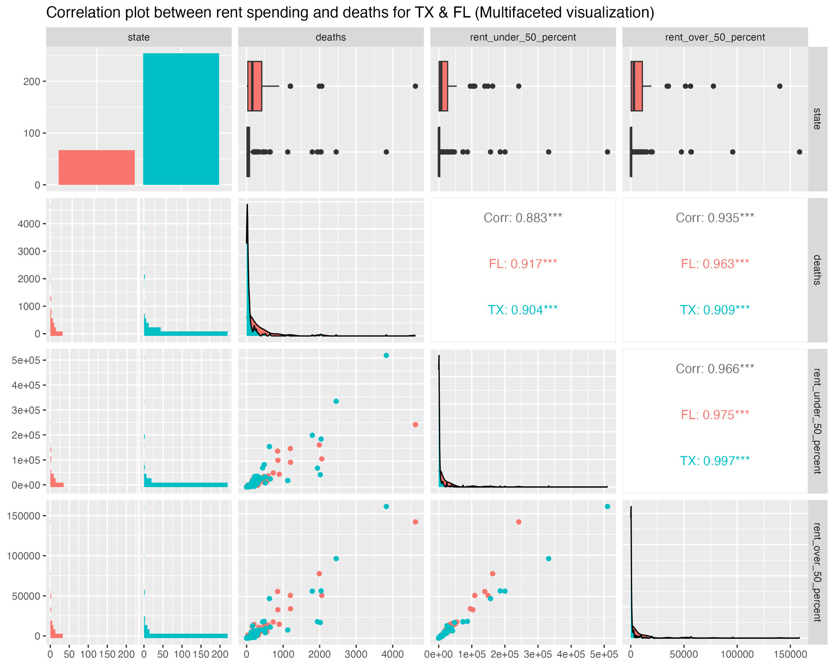

Fig: Correlation between rent spending and deaths

The above two correlation plots show correlation between the number of deaths and population spending over or under 50% of their income on rent. Previously, we looked into the correlation between the income and the deaths/confirmed cases for these states. Both of the above charts still support the fact that there is a stronger correlation with population spending more than 50% of their income on rent as compared to the population spending less than 50% of their income on rent. But for Texas, this difference is quite small as compared to Florida. In Texas, people spending less than 50% on rent even seem to have lower correlation with the confirmed cases. But people spending more than 50% on rent were still dying more in Texas. Overall, there is a significant difference between the correlation values between the population spending 50% or more on rent. Thus, we can say that more people, who spent more than 50% on their rents, got infected and died of the disease.

## Modeling and Evaluation

[**Modeling and Evaluation**: What type of model do we apply to the data?

Describe why you chose the particular model, model assumption and limitations, what variable you use for the model, and how well the model works. ]

# Recommendations

[Deployment: Describe how to interpret the model and what **recommendations** you can make based on the findings. How would the stakeholder use the findings and why is the recommendation useful to the stakeholder.]

# Conclusion

[Does the project answer the initial questions? Repeat the key findings and why they are important.]

# List of References

[Cite sources of information in your document and but complete references here. You may use any citation style as long as you are consistent. You can find the basics about how to properly cite references using APA style [here](https://owl.purdue.edu/owl/research_and_citation/apa_style/apa_formatting_and_style_guide/in_text_citations_the_basics.html). ]

Google. (n.d.). *Global mobility report*. Retrieved October 1, 2024, from <https://www.google.com/covid19/mobility/index.html>

U.S. Department of Health and Human Services. (2024). *U.S. spending on COVID-19 as of October 2024*. Retrieved October 1, 2024, from USASPENDING.gov: The Federal Response to COVID-19.

USA Facts link: <https://usafacts.org/visualizations/coronavirus-covid-19-spread-map/>

USAFacts US Coronavirus Database: <https://console.cloud.google.com/marketplace/details/usafacts-public-data/covid19-us-cases?filter=solution-type:dataset&filter=category:covid19&id=3eaff9c5-fbaf-47bb-a441-89db1e1395abhttps:%2F%2Fusafacts.org%2Fissues%2Fcoronavirus%2F&pli=1&project=crucial-cycling-338005>

# Appendix

[Put code and long tables that you do not need inside your report here. ]

| State Level Fips Code | State |
| --- | --- |
| 1 | ALABAMA |
| 2 | ALASKA |
| 4 | ARIZONA |
| 5 | ARKANSAS |
| 6 | CALIFORNIA |
| 8 | COLORADO |
| 9 | CONNECTICUT |
| 10 | DELAWARE |
| 11 | DISTRICT OF COLUMBIA |
| 12 | FLORIDA |
| 13 | GEORGIA |
| 15 | HAWAII |
| 16 | IDAHO |
| 17 | ILLINOIS |
| 18 | INDIANA |
| 19 | IOWA |
| 20 | KANSAS |
| 21 | KENTUCKY |
| 22 | LOUISIANA |
| 23 | MAINE |
| 24 | MARYLAND |
| 25 | MASSACHUSETTS |
| 26 | MICHIGAN |
| 27 | MINNESOTA |
| 28 | MISSISSIPPI |
| 29 | MISSOURI |
| 30 | MONTANA |
| 31 | NEBRASKA |
| 32 | NEVADA |
| 33 | NEW HAMPSHIRE |
| 34 | NEW JERSEY |
| 35 | NEW MEXICO |
| 36 | NEW YORK |
| 37 | NORTH CAROLINA |
| 38 | NORTH DAKOTA |
| 39 | OHIO |
| 40 | OKLAHOMA |
| 41 | OREGON |
| 42 | PENNSYLVANIA |
| 44 | RHODE ISLAND |
| 45 | SOUTH CAROLINA |
| 46 | SOUTH DAKOTA |
| 47 | TENNESSEE |
| 48 | TEXAS |
| 49 | UTAH |
| 50 | VERMONT |
| 51 | VIRGINIA |
| 53 | WASHINGTON |
| 54 | WEST VIRGINIA |
| 55 | WISCONSIN |
| 56 | WYOMING |

Table: State Level Fips Code

## 7.1 Student Contributions

Add a list with who contributed to what part of this report.